Samenvatting Cisco

# Chapter 1

## Exploring the Network

### Introduction

## Globally Connected

### Networking Today

Communication = very important

Communication method changing and evolving => technology

|  |  |  |
| --- | --- | --- |
| **Examples communication** | | |
| **Instant Messaging(IM)/texting** | **Social Media** | **Collaboration tools** |
| Real time communication  File transfer  Additional voice/video comm | Interactive websites | Shared documents  Speak (via video)  Share text/images |
| **Weblogs(blogs)** | **Wikis** | **Podcasting** |
| Easy to update/edit | Easy to edit/view  Group creation | Audio-based medium |
| **Peer-to-Peer(P2P) File sharing** |  |  |
| Sharing files without central server |  |  |

### Providing Resources in a Network

Home office networks and small office networks setup by individuals that need to connect to corporate network

Internet = network of networks => collection of interconnected private/public networks

All computers connected to network are hosts/end devices

Host: sending and receiving messages

End devices: can act as a client, server or both

Server: hosts that have software that enables them to provide info to other hosts on the network. Server can have many clients, and server can offer multiple services

Client: computer hosts that have software that enables them to request and display info obtained from server (eg. Internet Explorer). Client computer can run multiple client software

Client/server mostly on different computers, but possible to carry both => peer-to-peer network

* Simplest peer to peer: 2 directly connected computers (wire and wireless possible)
* Multiple pc’s requires a device (hub)

|  |  |
| --- | --- |
| **Advantages** | **Disadvantages** |
| Easy to setup | No centralized administration |
| Less complexity | Not as secure |
| Lower cost => no dedicated servers | Not Scalable |
| Can be used for file transfer and printer sharing | Slowed down performance due to client softw |

## LAN’s WAN’s, and the Internet

### Components of a Network

Network infrastructure contains three categories of network components

* Devices
  + Physical elements network (laptop, switch, router)
  + End devices: computers, network printers, security cameras
* Media
  + Physical elements network (unless wireless = radio freq/infrared waves)
* Services (network components)
  + Communication software



Host device is source/destination of transmitted message

* Distinguishing between hosts: address

Intermediate devices interconnect end devices (switches, routers, firewalls,…)

|  |  |  |
| --- | --- | --- |
| **Processes running on intermediary network devices perform these functions** | | |
| Regenerate and retransmit data | Maintain info about existing pathways | Notify other devices of errors/comm failures |
| Directing through alternative pathways (when error) | Classify/direct messages according to Quality of Service priorities (Qos) | Permit or deny flow of data (security settings) |

|  |  |  |
| --- | --- | --- |
| **Modern networks use three types of media to interconnect devices** | | |
| **Metallic wires (cables)** | **Glass or plastic fibers** | **Wireless transmission** |
| Electrical impulses | Pulses light (visible/invisible) | Electromagnetic waves |

|  |  |  |  |
| --- | --- | --- | --- |
| **Criteria choosing network media** | | | |
| Distance | Environment | Amount data and speed | Cost media |

Topology diagram: diagram of connections

|  |  |
| --- | --- |
| **Physical topology diagrams** | **Logical topology diagrams** |
| Identify physical location of intermediate devices, config ports and cable installation | Identify devices, ports and IP addressing scheme |

Symbols:







Network Interface Card – A NIC/LAN adapter -> physical connection to the network at the host device

Physical Port: Connector/outlet on networking device where media is connected to a host or other networking device

Interface: Speci alized ports on internetworking device that connect to individual networks. Routers interconnect networks => network interfaces

## LANs, WANs, and the Internet

### LANs and WANs

Two most common types of network infrastructures:

* Local Area Network (LAN) – Provides access to users/end devices in a small geographical area
  + Administrative control enforced on network level
  + High speed bandwidth to internal end devices
* Wide Area Network (WAN) – Provides access to other networks over wide geographical area
  + Administered by multiple service providers
  + Slower speed links between LANs

Other types of networks:

* Metropolitan Area Network (MAN) – Larger than LAN, smaller than WAN.
* Wireless LAN (WLAN) – wireless LAN
* Storage Area Network (SAN) –Support file servers and provide data storage, retrieval, and replication
* 

## LANs, WANs, and the Internet

### The Internet

Most individuals need to connect with a resource on another network outside local network => Internet

* Internet: worldwide collection of interconnected networks (internet: multiple networks interconnected; Internet: global system of interconnected networks, WWW)
* To ensure effective communication: application of consistent and commonly recognized technologies and standards => Internet Engineering Task Force (IETF), Corporation for Assigned Names and Numbers (ICANN), Internet Architecture Board (IAB)



Two terms similar to Internet:

* Intranet – Private connection of LANs and WANs that belong to someone
* Extranet – providing secure and safe access to individuals who work for different organization, but require company data



### Connecting to the Internet

Different ways to connect users and organizations to the Internet

* Home users, teleworkers, and small office require connection to an Internet Service Provider (ISP) to access Internet (Broadband cable, broadband digital subscriber line (DSL), wireless WANs, mobile services
* Organizations require fast connections to support various things. Business-class interconnections: Service providers (SP) (DSL, leased lines, Metro Ethernet)

Common connection options for small office and home office users

* Cable: Offered by cable tv service providers. High bandwidth. Special cable modem sperates the internet data signal from the other signals -> provides Ethernet connection
* DSL: high bandwidth. Requires a special high-speed modem that seperates the DSL signal from the telephone -> Ethernet connection. Telephone line divided in three channels: one for the telephone, second for downloading information, the third for uploading (slower than download). Speed depends on quality telephone line and distance from phone central office
* Cellular: Uses a cell phone network. Performance limited by capabilities phone and the cell tower. Advantage: internet in places where else no internet was
* Satellite: good option for homes which do not have access to DSL or cable. Require clear line of sight. Speed varies depending on the contract. Equipment and installation costs are high.
* Dial-up Telephone: Inexpensive. To connect to the ISP: user calls the ISP access phone number. Low bandwidth (ok for mobile)

Common connections for organizations:

* Dedicated Leased Line: dedicated connection from the service provider to the customer premise. Reserved circuits that connect geographically separated offices for private voice and/or data networking
* Metro Ethernet: Over a dedicated copper or fiber connection (10 Mb’s to 10 Gb’s). Ethernet over Copper (EoC) is more economical than fiber optic Ethernet service in many cases, but EoC is limited by distance
* DSL: Popular: Symmetric Digital Subscriber Lines (SDSL) => same upload as download speed
* Satellite: When wired solution is not available (see up). Connections tend to be slower and less reliable than its terrestrial competition

## The Network as a Platform

### Converged Networks

Early years of network: separate networks for data, telephone and video => no communication

Converged network: consolidating different networks onto one platform

* First phase in building the intelligent information network
* Next phase: consolidate the applications that generate, transmit and secure the messages onto integrated network devices
* 

### Reliable Network

Network architecture: technologies that support the infrastructure and the programmed services and rules/protocols

*Fault Tolerance*

* Limits the impact of failure, so that the fewest number of devices are affected by it
* Quick recovery when failures occur => if one path fails, try different path (although multiple paths to a destination = redundancy)
* **Circuit-Switched Connection-Oriented Networks**
  + Early telephone systems: call => setting up pathway, if something in pathway failed, connection was lost => circuit-switched process
  + Advantages:
    - Quality and consistency of the messages
    - Easier to charge, if a pathway needs to be reserved
  + 
* **Packet-Switched Networks**
  + After the early telephone stage: single message can be broken into multiple message blocks => each block contains the addressing info (IP addresses)
  + Each packet independently sent from one location to another => which route
  + **

**

*Scalability*

* Internet needs to support the rapid growth of new devices/people without impacting the performance of the service
* Internet is scalable because of design of protocols and underlying technologies
  + Layered structure for addressing, for naming and for connectivity services
  + Ability to accept new products and applications
  + New protocols and addressing structures are under development to meet the increasing rate at which internet applications and services are being added
* **
* **
* **

**

*Quality of Service (QoS)*

* Higher expectations for the quality of the delivered services
* Packet-switched network architecture does not guarantee that all packets comprise a particular message will arrive on time, in the correct order, or just arrive
* Networks also need mechanisms to manage congested network traffic
  + Network bandwidth: number of bits that can be transmitted in a single second
    - Most cases: when volume of packets is greater than what can be transported => devices queue, or hold packets in memory until resources become available (if too many, packets will be dropped)
    - Solution: priority
      * Time-sensitive communication: telephone/video, high priority
      * Non time-sensitive communication: web page retrieval/email low priority
      * High importance to organization: production control/business transaction data high priority
      * Undesirable communication: peer-to-peer file sharing or live entertainment low/block priority

**

**

*Security*

* Two types of network security
  + Network infrastructure security
    - Physical securing of devices and preventing unauthorized access to the management software
  + Information security
    - Protecting information contained within the packets being transmitted and the info stored on network attached devices
      * Prevent unauthorized disclosure
      * Prevent theft of information
      * Prevent unauthorized modification of information
      * Prevent Denial of Service (DoS) (sending enormous amounts of requests, preventing the server to respond to real requests)
    - Three primary requirements
      * Ensuring confidentiality: authorization to do something. Accomplished by having a strong system for user authentication, strong passwords and changing them frequently + encrypting data
      * Maintaining communication Integrity: assurance that the info has not been altered in transmission. Validation
      * Ensuring availability: against attacks that kill the whole system

**

## The Changing Network Environment

### Network Trends

**Bring Your Own Device (BYOD)**

* Freedom to use personal tools to access info and communicate across a business or campus network

**Online Collaboration**

* The act of working with another or others on a joint project
* Benefits:
  + Improve customer satisfaction -> online presence and communication mech
  + Increase communication choices
  + Optimize team performance
  + Enable mobile users
  + Improve organizational communications
  + Transform training and event management
  + Improve facility management
* Video -> communication/collaboration/entertainment

**Cloud Computing**

* Use of computing resources that are delivered as a service over a network
* Term refers to web-based computing
* Potential benefits:
  + Organizational flexibility: info can be accessed anytime and anyplace with web browser
  + Agility and rapid deployment
  + Reduced cost of infrastructure: Technology moved to a cloud provider
  + Refocus of IT resources: cost savings
  + Creation of new business models: companies can react quick to customers’ needs
* Cloud computing possible because of data centers
  + Data center: facility to house computer systems and associated components
    - Redundant data communication connections
    - High speed virtual servers
    - Redundant storage systems
    - Redundant or backup power supplies
    - Environmental controls (airco, fire suppression)
    - Security devices
  + Modern data centers use virtualization =>creation of a virtual version of something => running several OS’s on a single CPU (instead of running several programs on a single OS

### Networking Technologies for the home

Smart home technology -> technology that is integrated into everyday appliances

Powerline networking: using electrical wiring to connect devices (similar to DSL)

* Homeplug: devices can connect to the LAN if there is an electrical outlet
  + Ok if no other option is viable

**Wireless Internet Service Provider (WISP)**

* Is an ISP that connects subscribers to a designated access point/hotspot using similar wireless technologies found in home wireless local area networks (WLANs)
* More in rural environments

**Wireless Broadband Service**

* For home and small business
* Same cellular technology used to access internet via a smartphone

### Network Security

Most common external threats:

* Viruses, worms and Trojan horses: code running on a user device
* Spyware and adware: software installed on user device that collects info
* Zero-day attacks (zero hour attacks): an attack that occurs on the first day that a vulnerability becomes known
* Hacker attacks: no comment
* Denial of service attacks: attacks designed to slow/crash applications and processes on a network device
* Data interception and theft: attack to capture private info
* Identity theft: attack to steal the login credentials

Important to consider internal threats => most common data breaches happen because of internal users of the network => BYOD makes corporate data more vulnerable



* Home network: basic => network security implemented on connection host devices and on the point of connection to the internet
  + Minimum
    - Antivirus and antispyware
    - Firewall filtering: to block unauthorized access to the network
* Corporate network: many components
  + The above +
    - Dedicated firewall systems
    - Access Control Lists (ACL)
    - Intrusion Prevention System (IPS): to identify fast spreading threats such as zero day attacks
    - Virtual private networks (VPN): provide secure access to remote workers

### Network Architecture

Network architecture= devices, connections and products that are integrated to support the necessary technologies and applications

# Chapter 2: Configuring a Network Operating System

## 2.0.1 Introduction

### 2.0.1.1 Introduction to Cisco IOS

**Home networks** interconnect wide variety of end devices, all these devices are connected to a home router. Home routers are four devices in one:

* Router: Forwards data packets to and receives data packets from the Internet
* Switch: Connects end devices using network cables
* Wireless access point: Consists of radio transmitter capable of connecting end devices wirelessly
* Firewall appliance: Secures ongoing traffic and restricts incoming traffic

**Business networks**:

* Pc’s, laptops connected to network switches using wired connections
* Switches connected to routers => sending packets beyond local network
* Dedicated security devices

Operating systems are used on all end user (smartphones, tablets,.. ) and network device (switches, routers, wireless access points and firewalls)connected to the internet. Operating System on a network device = network operating system. For CISCO: Cisco IOS

### 2.0.1.2 Class Activity – It is just an operating system

# 2.1 IOS Bootcamp

## 2.1.1 CISCO IOS

### 2.1.1.1 Operating System

Operating system needed to help end devices performing their function

How does an operating system work?

* Computer loads the OS from a disk drive into RAM
  + Portion of the OS code that interacts directly with the hardware: kernel
  + Portion that interfaces with the application and user: shell -> can be interacted with via command-line interface (CLI) or graphical user interface (GUI)

The CLI:

* User interacts directly with the system text-based environment -> commands at command prompt
* User gets textual output

The GUI:

* Environment that uses graphical images, multimedia and text
* More user friendly, requires less knowledge of the command structure

Operating system on home routers = firmware

* Most common method of configuring a home router = using a web browser to access an easy to use GUI
* Most home routers enable the ability to update the firmware

Infrastructure network devices use a network operating system

* Cisco uses: Cisco Internetwork Operating System (IOS)

### 2.1.1.2 Purpose of OS

Operating systems enable us to:

* Use a mouse
* View output on a monitor
* Enter text commands
* Select options within a dialog box window

The same is true for functions for switches and routers -> providing the technician with an interface

CISCO IOS is a term that encompasses a number of different operating systems that run on various network devices: (can be upgraded)

* IOS for switches, routers and other Cisco networking devices
* IOS numbered versions for a given Cisco networking device: depends on the type of device
* IOS feature sets providing distinct packages of features and services

This course: Cisco IOS release 15.x

### 2.1.1.3 Location of Cisco IOS

The IOS itself: several megabytes, stored in a semi-permanent memory area: flash

* Flash memory provides non-volatile storage -> contents not lost when the device loses power
* Flash can be changed/overwritten
* Flash can be used to store multiple versions of the IOS software at the same time

How does it work?

* IOS copied from flash into random access memory (RAM)
* Running IOS in RAM increases performance of the device
* But RAM is volatile memory: data is lost during a power cycle
  + Power cycle: device is powered off and then powered back on

The quantity of flash memory and RAM memory required for a given IOS varies dramatically

### 2.1.1.4 IOS Functions

Major functions performed/enabled by Cisco routers and switches: (generally accessed using CLI)

* Providing network security
* IP addressing of virtual and physical interfaces
* Enabling interface-specific configurations to optimize connectivity of the respective media
* Routing
* Enable quality of Service (QoS) technologies
* Supporting network management technologies

## 2.1.2 Accessing a Cisco IOS Device

### 2.1.2.1 Console Access Method

Ways to access the CLI environment

* Console
* Telnet or SSH
* AUX port

**Console**

Console port is a management port that provides out-of band access to Cisco device

* Out-of-band access refers to access via a dedicated management channel that is used for device maintenance purposes only

Advantage:

* The device is accessible is accessible even if no networking services have been configured
  + Initial configuration: computer running terminal emulation software is connected to the console port of the device using a special cable
    - Configuration commands for setting the switch/router up can be entered on the connected computer
  + When networking services have failed and remote access of the Cisco IOS device is not possible
    - Computer can determine the status of the device

For many IOS devices, console access does not require any form of security

* Console should however be configured with passwords to prevent unauthorized device access
* In case of lost password: procedure for bypassing the password
* Device should be located in a locked room, to prevent unauthorized physical access

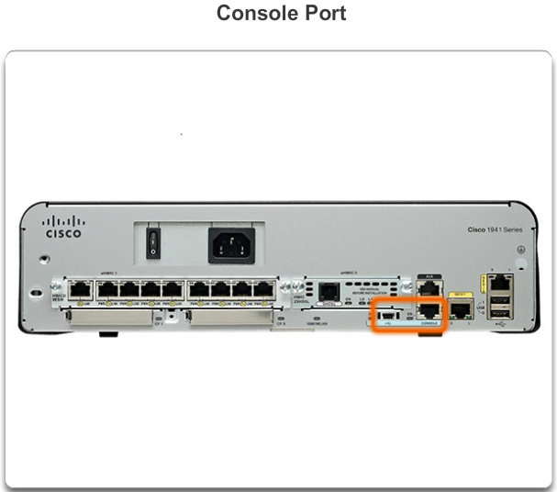

### 2.1.2.2 Telnet, SSH and AUX Access Methods

**Telnet**

Method for remotely establishing a CLI session of a device through a virtual interface, over a network

* Requires active networking services
  + Network device must have at least one active interface configured with an Internet address (such as an IPv4 address)

Cisco IOS devices include a Telnet Server process -> allows users to enter configuration commands from a Telnet Client

Cisco IOS devices contain also a Telnet client -> allows network administrator to telnet from the Cisco device CLI to any other device that supports a Telnet server process

**SSH -> use this instead of Telnet**

The Secure Shell (SSH) protocol provides a remote login, similar to Telnet, except that it uses more secure network services

* Stronger password authentication than Telnet
* Encryption when transporting session data

Some devices require to set the SSH server to be enabled manually

IOS devices also have a SSH client -> used to establish SSH sessions with other devices

**AUX**

Older way to establish a CLI session remotely -> telephone dialup connection using a modem connected to the auxiliary port of a router

* Out-of_band connection -> no networking services needed

AUX port can also be used locally, like the console port, with a direct connection to a computer running a terminal emulation program

* Console port preferred over the AUX port -> console port displays startup, debugging and error messages by default

Cisco Catalyst switches do not support an auxiliary connection

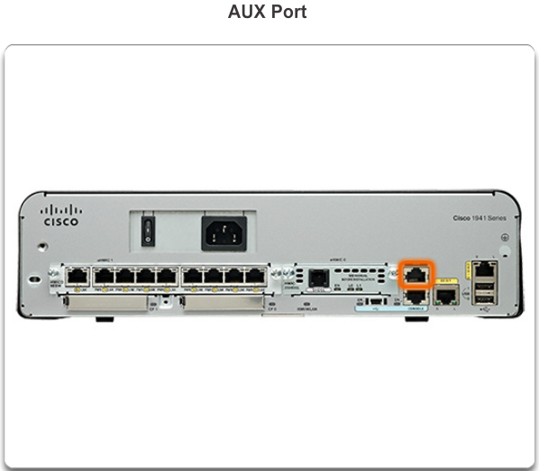

### 2.1.2.4 Terminal Emulation Programs

Terminal emulation programs available for connecting to a networking device either by serial connection over a console port or by a Telnet/SSH connection

* PuTTY
* Tera
* SecureCRT
* HyperTerminal
* OS X Terminal

### 2.1.2.5 Activity – Accessing Devices

## 2.1.3 Navigating the IOS

### 2.1.3.1 Cisco IOS modes of operation

The CLI uses a hierarchical structure for modes. From most basic to more specialized

* User executive (User EXEC) mode
* Privileged executive (Privileged EXEC) mode
* Global configuration mode -> configure settings that affect the device as a whole
* Other specific configuration modes, such as interface configuration mode

Each mode has a distinctive prompt and is used to accomplish particular tasks with a specific set of commands that are available to only that mode

* 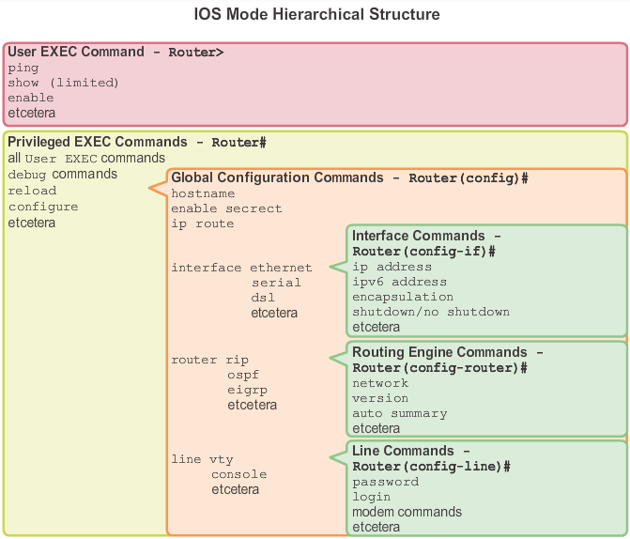Different authentication can be required for each hierarchical mode

### 2.1.3.2 Primary Modes

Two primary modes of operation are: user EXEC mode and priviliged EXEC mode

**User EXEC Mode**

View-only mode, this level does not allow the execution of any commands that might change the configuration of the device

Default: no authentication required to enter this mode, but it’s good practice to ensure that authentication is configured during initial configuration

Symbol: ends at >

**Privileged EXEC Mode**

Prompt ends at #

By default: no authentication is required -> good practice to configure authentication

### 2.1.3.3 Global Configuration Mode and Submodes

Can only be reached from the privileged EXEC mode

**Global Configuration Mode**

From here CLI configuration changes are made that affect the operation of the device as a whole

Command used to take the device from privileged EXEC mode to global configuration mode:

* **Configure terminal**
  + After command is executed, prompt changes to (config)#

**Specific Configuration Modes**

From the global configuration mode, the user can enter different sub-configuration modes

* Interface mode: to configure one of the network interfaces (Fa0/0, S0/0/0)
* Line mode: to configure one of the physical or virtual lines (console, AUX, VTY)

To exit a specific configuration mode: exit

To leave configuration mode completely (return to privileged EXEC mode): end (or Ctrl-Z)

**Command Prompts**

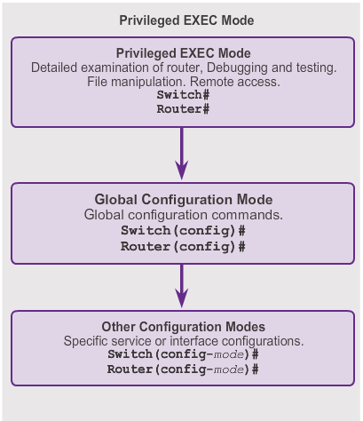Default: every prompt begins with the device name, all the following describes the mode

### 2.1.3.4 Navigating between IOS Modes

**Moving between the User EXEC and Privileged EXEC Modes**

Enable and disable commands used to change the CLI between user EXEC mode and the privileged EXEC mode (that is why the privileged EXEC mode is called the enable mode)

* If password authentication is configured, password will be asked

**Moving from and to Global Configuration Mode and Submodes**

To quit from the global configuration mode and return to the privileged EXEC mode, enter exit

* If you enter exit in privileged EXEC mode, the console session ends!
* Enter enter when you start console session to go in User EXEC mode

To move from any submode of the privileged EXEX mode to the privileged EXEC mode, enter the end command or Ctrl+Z

To move from any submode of the global configuration mode to another immediate submode of the global configuration mode, enter the corresponding command

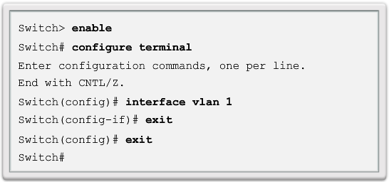

## 2.1.4 The Command Structure

### 2.1.4.1 IOS Command Structure

**Basic IOS Command Structure**

Commands are not case-sensitive , following the command, there could be keywords/arguments

Press enter to submit the command

* Keywords describe specific parameters to the command interpreter
  + Show command used to display info about the device
    - Many keywords can follow the command, such as running-config

**IOS Command Conventions**

Argument is generally not a predefined word

* Description takes a string
* Ping takes an ip-address, no quotes
* Traceroute takes an ip-address, no quotes

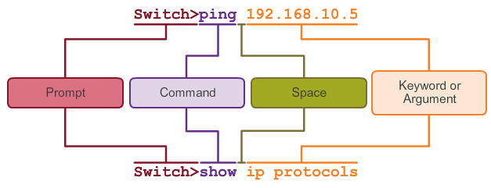

### 

### 2.1.4.2 Cisco IOS Comand Reference

Collection of online documentation which describes in detail the IOS commands. Very useful to check various characteristics of a given IOS command like:

* Syntax
* Default
* Mode
* History: descriptions of how the command is implemented relative to the IOS version
* Usage Guidelines: guidelines describing specifically how to implement the command
* Examples

### 2.1.4.3 Context-Sensitive Help

**Context-Sensitive Help**

Provides a list of commands and the associated arguments within the context of the current mode

* 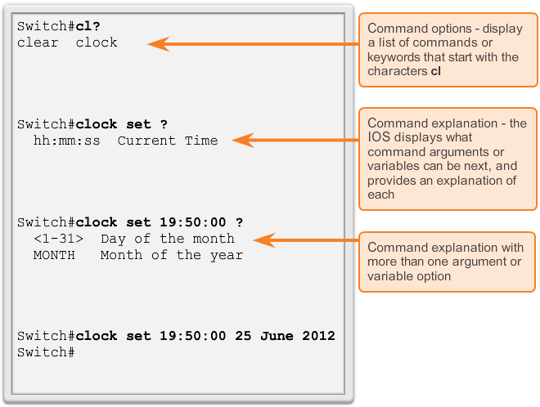Enter ? at any prompt, no need to enter, immediate response

Display a list of commands/keywords that start with a specific character or characters

* Enter character sequence, followed by an immediate ?

Determining which options, keywords or arguments are matched with a specific command

### 2.1.4.4 Command Syntax Check

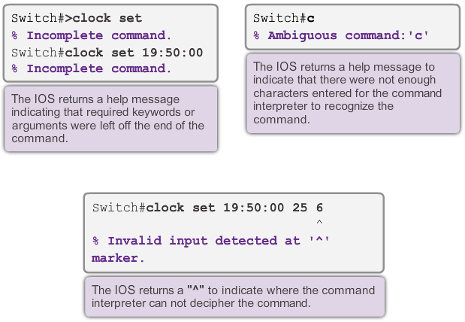

### 2.1.4.5 Hot Keys and Shortcuts

* Down arrow: Allows the user to scroll forward through former commands (Ctrl-N)
* Up arrow: Allows the user to scroll backward through former commands (Ctrl-P)
* Tab: Completes the remainder of a partially typed command or keyword
* Ctrl-A: Moves to the beginning of the line
* Ctrl-E: Moves to the end of the line
* Ctrl-R: Redisplays a line -> when you type a line, but CLI just gave you output (overwriting your line), Ctrl-R will restore your line
* Ctrl-Z: Exits the configuration mode and returns to privileged EXEC mode
* Ctrl-C: Exits the configuration mode or aborts the current command
* Ctrl-Shift-6: Allows the user to interrupt an IOS process such as ping or traceroute

**Abbreviated commands or keywords**

Commands and keywords can be abbreviated to the minimum number of characters that identify a unique selection -> configure can be abbreviated by conf

* You can abbreviate both command and the keywords:
  + Sh int

### 2.1.4.6 IOS Examination Commands

Basic examination command = show

* Use show ? to get a list of available commands in the given context, or mode
* Show interfaces -> statistics for all interfaces on the device
  + To view statistics for a specific interface: show interface *specificInterface* + *slot/port number*
  + Show startup-config -> displays the saved configuration located in NVRAM
  + Show running-config -> displays the contents of the currently running configuration file

**The More Prompt**

When a command returns more output than can be displayed on a single screen -> --More—

* Press space bar to view the next portion
* To display only the next line: press enter
* 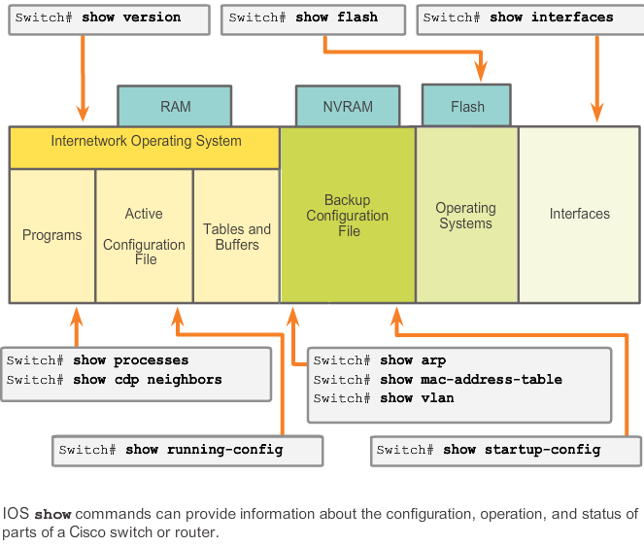If you press something else, the output is canceled

### 2.1.4.7 The show version Command

Show version

* Displays info about the currently loaded IOS version, along with hardware and device information
  + Software version: IOS software version (stored in flash)
  + Bootstrap version (stored in BOOT ROM)
  + System up-time: time since last reboot
  + System restart info: Method of restart
  + Software image name: IOS filename stored in flash
  + Router type and processor type: Model number and processor type
  + Memory type and allocation (shared/main): Main processor RAM and Shared Packet I/O buffering
  + Software features -> supported protocols/feature sets
  + Hardware interfaces -> interfaces available on the device
  + Configuration register -> Sets bootup specifications, console speed settings and related parameters

# 2.2 Getting Basic

## 2.2.1 Hostnames

### 2.2.1.1 Why the Switch

Cisco IOS switch is one of the simplest devices that can be configured on a network -> no configurations that are required prior to device functioning

### 2.2.1.2 Device Names

First step is configuring an unique device name, or hostname.

Hostnames appear in CLI prompts and can be used in various authentication processes between devices and should be used on topology diagrams

* Default name for a Cisco IOS switch -> switch -> if you have a lot of switches, this will give trouble
* Try using a naming convention that spans the company or at least the location
  + Start a letter
  + Contain no spaces
  + End with a letter or digit
  + Use only letters, digits and dashes
  + Less than 64 characters

### 2.2.1.3 Hostnames

### 2.2.1.4 Configuring Hostnames

**Configure IOS Hostname**

From privileged EXEC mode enter global configuration mode by entering: configure terminal

Enter the hostname: hostname Sw-Floor1 -> Prompt will change to: Sw-Floor-1(config)#

* To undo the effects of a command, preface the command with the no keyword: no hostname

## 2.2.2 Limiting Access to Device Configurations

### 2.2.2.1 Securing Device Access

Passwords introduced here:

* Enable password: limits access to privileged EXEC mode
* Enable secret: Encrypted, limits access to privileged EXEC mode
* Console password: Limits device access using console connection
* VTY password: limits device access over Telnet

Good practice: use different authentication passwords for each level of access

Keypoints when choosing passwords:

* Use passwords that are more than 8 characters in length
* Use a combi of upper, lowercase letters, numbers, special characters and/or numeric sequences
* Avoid using the same password for all devices
* Avoid using common words

### 2.2.2.2 Securing Privileged EXEC Access

Enable secret *password*  command -> encrypted

* Older less secure variation of command: enable password *password* -> not encrypted

### 2.2.2.3 Securing User EXEC Access

Console port of network devices must be secured. In global configuration mode:

* Line console 0 -> enter line configuration mode for the console, 0 is first (and mostly only) console interface
* Password *password*
* Login ->configures the switch to require authentication upon login

**VTY password**

Default Cisco switches: support up to 16 vty lines (0 15)

Default Cisco router: 5 most common

* Line vty 0 15
* Password *password*

### 2.2.2.4 Encrypting Password Display

Command that prevents passwords from showing up as plain text when viewing configuration files: service password-encryption

* Weak encryption to all unencrypted passwords
* Applies only to passwords in the configuration file, not passwords as they are sent over media

If you run show running-config or show startup-config prior to service password-encryption -> unencrypted passwords are visible in configuration output

* Once encryption has been applied, removing the encryption service does not reverse the encryption

### 2.2.2.5 Banner Messages

Declaring that only authorized personal should attempt to gain entry into the device -> can be important of the legal process!!

* Any wording that implies that a login is “welcome” or invited” is not appropriate
* Banner can include scheduled system shutdowns

Common banner: message of the day (MOTD) -> often used for legal notification because it is displayed to all connected terminals

* Banner motd command from global configuration mode
  + Followed by a space and a delimiting character, then one or more lines of text, second occurrence of the delimiting character -> # often used as delimiting character

## 2.2.3 Saving Configurations

### 2.2.3.1 Configuration Files

Modifying a running configuration affects the operation of Cisco immediately

* Stored in the working memory of the device -> but if power is lost, then all configuration changes are lost, unless they have been saved

After making changes to a running configuration file there are three options:

* Return to it’s original configuration
* Remove all configurations from the device
* Make the changed configuration the new startup configuration -> NVRAM (nonvolatile)

Before committing to the changes, use the show commands to verify the device’s operation

* Show running-config -> if changes are correct -> copy running-config startup-config at privileged EXEC mode
  + If changes are not good: reload command at privileged EXEC mode -> IOS will detect that you have made changes to the running config and has not been saved, prompt will ask to save -> press n or no for discarding
    - Additional prompt will appear to confirm -> press enter to confirm, any other key will abort the process

Startup-configuration is removed by using erase startup-config at privileged EXEC mode

* Variant: erase NVRAM:startup-config
  + Confirm the erase by pressing enter
* On switch: use also the delete vlan.dat command in addition to the erase startup-config to return the device to factory settings
* Then use reload to remove the current running configuration file from RAM

Caution is needed with the erase command! Can be used to erase any file

### 2.2.3.2 Capturing Text

**Backup Configurations with Text Capture**

Configuration files can also be saved and archived to a text document

* On file menu: click log
* Choose the location. Tera Term will begin capturing text
* After capture has started, execute the show running-config or show startup-config command (privileged EXEC mode)
* When the capture is complete, select close in the Tera Term: log window
* View the output to verify that it was not corrupted

**Restoring Text Configurations**

Configuration file can be copied from storage to a device, when copied into the terminal, IOS executes each line of the configuration text as a command

* File requires probably editing before copying
* Advisable to change the encrypted passwords to plain text and remove the parameter (5 or 7) which specifies that the password is encrypted
* Non-command text such as –more—and IOS messages must be removed

At the CLI the device must be set at global configuration mode to receive the commands

When using Tera Term the steps are:

* Edit text to remove non-commands and save
* On the file menu, click send file
* Locate the file to be copied into the device and click open
* Tera term will paste the file into the device

# 2.3 Address Schemes

## 2.3.1 Ports and Addresses

### 2.3.1.1 IP Addressing of Devices

Use of IP addresses (IPv4/IPv6) is the primary means of enabling devices to locate one another and establish end-to-end communication on the Internet

Structure of IPv4 address is called: dotted decimal notation -> 4 decimal numbers between 0 and 255

* Addresses assigned to individual devices, provide info about the location of the device
* IP addresses can be assigned to both physical ports and virtual interfaces on devices
  + Virtual: no physical hardware on the device associated with it

Subnet mask is also necessary -> special type of IPv4 address, coupled with IP address, determines which particular subnet or a larger network the device is a member

### 2.3.1.2 Interfaces and Ports

Each physical interface has specifications/standards that define it -> cable connecting to the interface must be designed to match the physical standards of the interface. Types of network media

* Twisted-pair copper cables
* Fiber optic cables
* Coaxial cables
* Wireless

Differences between various types of media:

* Distance the media can successfully carry a signal
* Environment in which the media is to be installed
* Amount of data and speed at which must be transmitted
* Cost of the media and installation Cost of the media and installation

Each link also requires a particular network technology

* Ethernet most common local area network (LAN) technology used today
  + Cable must have the correct connector: RJ-45

Cisco IOS switches have also one or more switch virtual interfaces (SVI’s)

* Provide a means to remotely manage a switch over a network using IPv4
* Default SVI is interface VLAN1

## 2.3.2 Addressing Devices

### 2.3.2.1 Configuring a Switch Virtual Interface

To access the switch remotely: an IP address and a subnet mask must be configured on the SVI:

* IP address: Together with subnet mask, uniquely identifies end device on the internetwork
* Subnet mask: Determines which part of a larger network is used by an IP address

Interface vlan 1 – used to navigate to the interface configuration mode from the global configuration mode

IP address 192.168.10.2.255.255.0 – Configures the IP address and subnet mask for the switch (many combo’s possible)

No shutdown – Administratively enables the interface to an active state

Note: Switch still needs to have one or more physical ports configured + VTY lines to complete the configuration which enables remote management of the switch

### 2.3.2.2 Manual IP Address Configuration for End Devices

In addition to IP address and subnet mask information, it is also possible to configure default gateway and DNS server information

* Default gateway address = IP address of the router interface used for network traffic to exit the local network
  + Often assigned by the network administrator and is used when traffic must be routed to another network
* 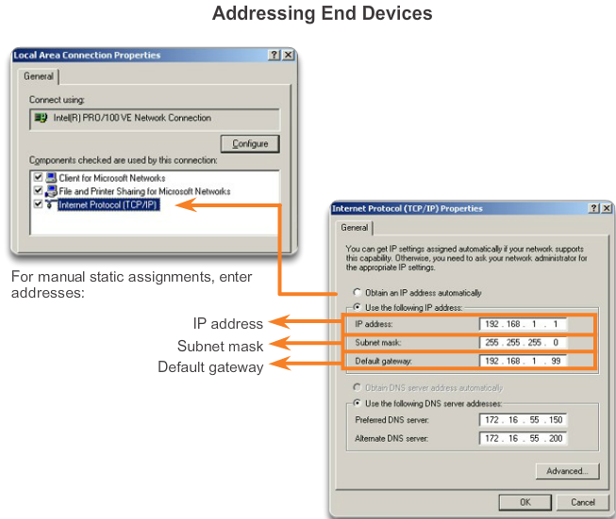DNS server address is the IP address of the Domain Name System (DNS) server, which is used to translate IP addresses to web addresses

### 2.3.2.3 Automatic IP Address Configuration for End Devices

IP address info can be entered into the PC manually or using Dynamic Host Configuration Protocol (DHCP) -> automatic

Displaying IP configuration settings on a Windows PC -> ipconfig command

### 2.3.2.4 IP Address Conflicts

If a static (manual) IP address is defined for a network device, and then a DHCP server is installed, duplicate IP address conflicts may occur between the network device and a PC obtaining automatic IP addressing info from DHPC

* How to resolve?
  + Convert the network device with the static IP address to a DHCP client
  + or on the DHCP server, exclude the static IP address of the end device from the DHCP scope -> requires administrative privileges on the DHCP server

Note: Usually static IP addresses are used with servers/printers in a small-to medium-sized business network

## 2.3.3 Verifying Connectivity

### 2.3.3.1 Test the Loopback Address on an End Device

**Testing the Loopback**

Ping command used to verify the internal IP configuration on a local host

* 127.0.0.1 is defined by the TCP/IP protocol as a reserved address that routes packets back to the host -> ping 127.0.0.1 (ping yourself)
* Result, if successful, indicates that the network interface card, drivers and the TCP/IP implementation are all functioning correctly

### 2.3.3.2 Testing the Interface Assignment

**Verifying the Switch Interfaces**

Show ip interface brief command

**Testing PC-to-Switch Connectivity**

Ping from PC to the IP address of (S1 VLAN interface eg.)

**Testing End-to-End Connectivity**

If a PC can ping to another PC -> end to-end connectivity

# 2.4 Summary

## 2.4.1 Summary

### 2.4.1.3 Summary

Services provided by the Cisco IOS are accessed using a command-line interface (CLI), which is accessed by the console port, the AUX port or telnet or SSH

# 3.0 Network Protocols and communications

## 3.0.1 Introduction

# 3.1 Rules of Communication

## 3.1.1 The Rules

### 3.1.1.1 What is Communication

A physical connection between end devices is not enough to enable communication -> devices must know how to communicate. All communication methods have three elements in common

* Message source, the sender -> people/electronic devices that need to send something
* Destination, receiver -> receives the message and interprets it
* Channel -> media that provides the pathway over which the message travels

Sending of a message is governed by rules called protocols -> specific to the type of communication method occurring

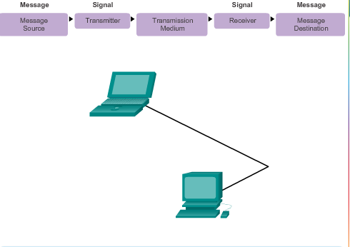

### 3.1.1.2 Establishing the Rules

Protocols used are specific to the characteristics of the communication method

Human Protocols must account for the following requirements:

* An identified sender and receiver
* Common language and grammar
* Speed and timing of delivery
* Confirmation or acknowledgement requirements

Computer protocols include:

* Message encoding
* Message formatting and encapsulation
* Message size
* Message timing
* Message delivery options

### 3.1.1.3 Message Encoding

Encoding is the process of converting information into another acceptable form, for transmission. Decoding reverses the process in order to interpret the information

* Human example:
  + Encoding: encoding thoughts, perceptions into words
  + Transmitting: speaking through the telephone
  + Transmission medium: the phone, sound
  + Receiver: the other person
  + Decoding: translating the sounds in order to visualize the picture
* Computer example
  + Encoding: first converted into bits, then into sounds, light waves or electrical impulses -> depends on the network media
  + Transmitting: sending the info
  + Transmission media: wireless, copper cable, optic fiber
  + Receiver: other host
  + Decoding: decoding the signal

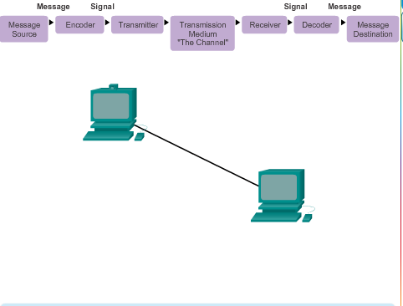

### 3.1.1.4 Message Formatting and Encapsulation

When a message is sent from source to destination: it must use a specific format or structure

* Depends on the type of message and the channel that is used
* Human example: Letter writing: standardized form how it should be done, else the letter won’t go to the destination
  + Process of placing one message format (letter) inside another message format (envelope) = encapsulation
  + De-encapsulation: reversed process done by the recipient

Each computer message is encapsulated in a specific format: a frame before it is sent over the network

* Frame acts like an envelope -> provides the address of the intended destination and the address of the source host
* Format and content of a frame are determined by the type of message and the channel

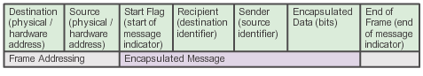

### 3.1.1.5 Message Size

When people communicate with each other, the messages that they send are usually broken into smaller parts or sentences -> same goes with computers

* Rules over the size of a message are very strict -> too long/too short and the message is not delivered
  + Can vary over the channel that is used

Segmenting: breaking a long message into individual pieces

* Each segment is encapsulated in a separate frame

### 3.1.1.6 Message Timing

**Access Method**

This determines when someone is able to send a message

* Hosts on a network need an access method to know when to begin sending messages and how to respond when errors occur

**Flow Control**

Timing also affects how much information can be sent and the speed that it can be delivered

* Humans: Too quickly -> difficult to hear and understand
* Network: sending host can transmit messages at a faster rate than the destination host can receive and process -> source and destination hosts use flow control to negotiate correct timing

**Response Timeout**

Hosts on a network have rules that specify how long to wait for responses and what action to take if a response timeout occurs

### 3.1.1.7 Message Delivery Options

Unicast = one-to-one delivery

Multicast = one-to-many delivery

Broadcast = one-to-all delivery

Acknowledged delivery option: receiver needs to send an acknowledgement back to the sender

* Unacknowledged: no need for an acknowledgement

# 3.2 Network Protocols and Standards

## 3.2.1 Protocols

### 3.2.1.1 Protocols: Rules that Govern Communications

A Group of inter-related protocols necessary to perform communication function = protocol suite

* Implemented by hosts and network devices in software, hardware or both

Protocol stack -> protocols viewed in terms of layers –> higher levels depend on lower levels

* Lower levels -> moving data over the network and providing service to upper levels
  + Human example: 2 people with a voice that can say words out loud
* Upper levels -> focused on the content of the message
  + Human example: The words that are actually spoken

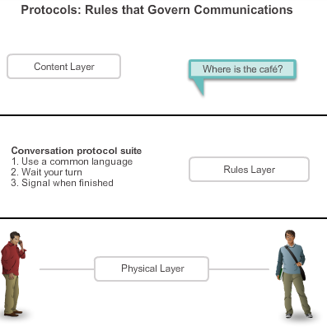

### 3.2.1.2 Network Protocols

Common networking protocols: IP, HTTP, DHCP

* How the message is formatted or structured

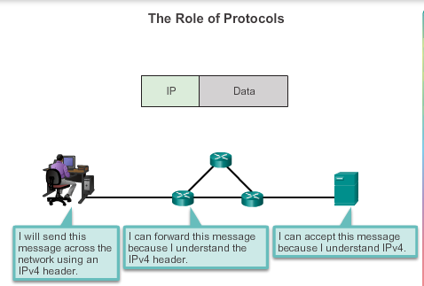

* Process by which networking devices share information about pathways with other networks

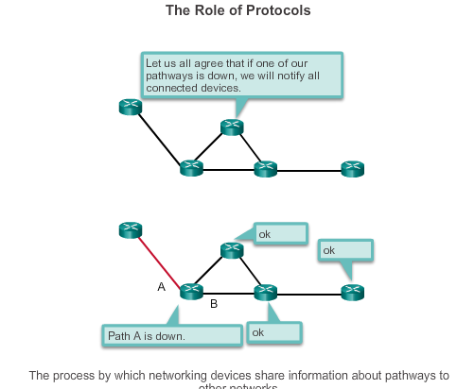

* How and when error and system messages are passed between devices

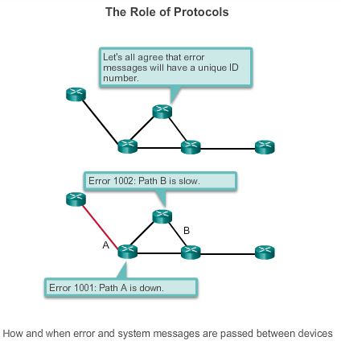

* The setup and termination of data transfer sessions

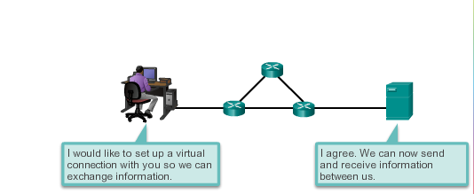

### 3.2.1.3 Interaction of Protocols

An Example of using the protocol suite in network communications is the interaction between a web server and a web client. Examples of these protocols are:

* Application Protocol: Hypertext Transfer Protocol (HTTP): HTTP defines the content and formatting of the requests and responses that are exchanged between client and server.
* Transport Protocol: Transmission Control Protocol (TCP): TCP divides the HTTP messages into smaller pieces (segments). Segments sent between the web server and client processes. TCP also responsible for controlling the size and rate at which messages are exchanged
* Internet Protocol: IP is responsible for taking the formatted segments from TCP, encapsulating them into packets, assigning them to the appropriate addresses, and delivering them across the best path to the destination host
* Network Access protocols: Two primary functions: Communication over a data link and the physical transmission of data on the network media
  + Data link management protocols take the packets from IP and format them to be transmitted over the media. Standards and protocols for the physical media govern how the signals are sent and interpreted -> Ethernet as example

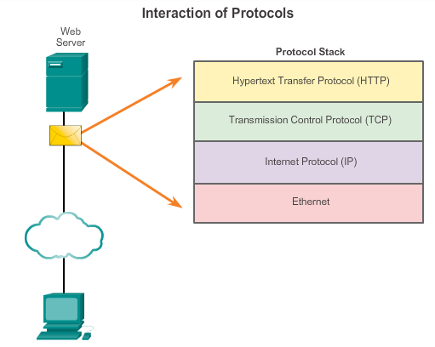

## 3.2.2 Protocol Suites

### 3.2.2.1 Protocol Suites and Industry Standards

Protocol suite Transmission Control Protocol/IP (TCP/IP): IP, HTTP and DHCP

* Open standard: freely available to the public, everybody is able to implement this on their hardware/software

Standards-based protocol: process/protocol that has been endorsed by the networking industry and ratified or approved by a standards organization

* Use of standards ensures that products from different manufactures can interoperate successfully

Some protocols are proprietary -> one company or vendor controls the definition of the protocol and how it functions

* Some proprietary protocols can be used by different organizations with permission of the owner
* Other can only be implemented on equipment manufactured by the proprietary vendor -> AppleTalk and Novell Netware

Some companies may even work together to create a proprietary protocol

* Ethernet -> 802.3
* EIGRP routing protocol of Cisco

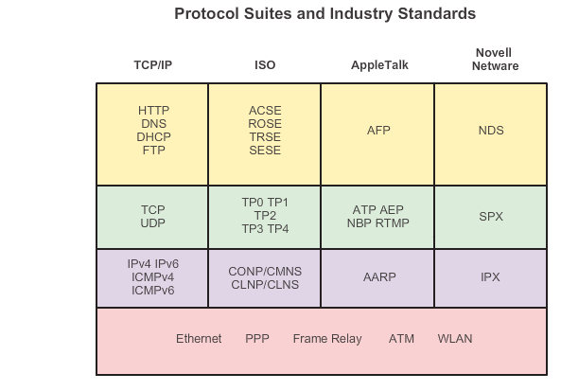

### 3.2.2.2 Creation of the Internet and Development of TCP/IP

IP suite = TCP/IP

* Open standards-based replaced other vendor proprietary protocol suites such as AppleTalk and Novell’s Internetwork Packet Exchange/Sequenced Packet Exchange (IPX/SPX)

Vieze history die ik niet kan volgen ☺

### 3.2.2.3 TCP/IP Protocol Suite and Communication Process

Lower layer protocols in the data link or network access layer are responsible for delivering the IP packet over the physical medium -> developed by standards organizations such as IEEE

Ethernet protocols 802.3 are used to transmit the IP packet over the physical medium used by the LAN

Example:

1. Web server’s Hypertext Markup Language (HTML) page is the data to be sent
2. The application protocol HTTP header is added in front of the HTML data. Header contains the HTTP version of the server and a status code -> indicates it has info for the web client
3. HTTP application layer protocol delivers the HTML-formatted web page data to the Transport layer. TCP transport layer protocol used to manage the individual conversation between web server and web client
4. IP information is added in front of TCP information -> appropriate source and destination IP addresses -> IP packet
5. Ethernet protocol adds information to both ends of the IP packet -> data link frame. Frame delivered to the nearest router along the path towards the web client. This router removes the Ethernet information, analyzes the IP packet, determines the best path, inserts the packet into a new frame -> to the next neighboring router towards destination. Each router removes and adds new data link information before forwarding the packet
6. This data is now transported through the internetwork -> media and intermediary devices
7. Client receives the data link frames that contain the data and each protocol header is processed and then removed in the opposite order that it was added -> first Ethernet, IP then TCP and then HTTP
8. Web page information passed on to the clients web browser software

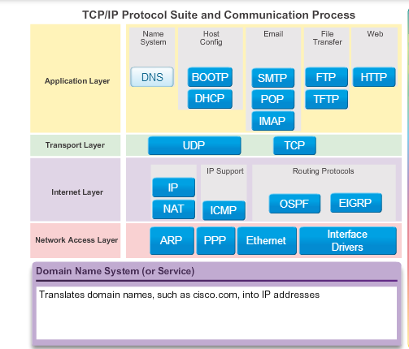

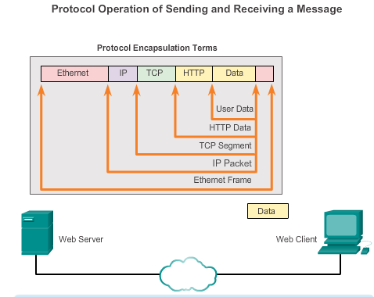

## 3.2.3 Standards Organizations

### 3.2.3.1 Open Standards

Encourage competition and innovation + guarantee that no single company’s product can monopolize the market or have an unfair advantage over its competition

* Example: there are different choices available for a wireless router from many vendors which all incorporate standard protocols such as IPv4, DHCP, 802.3 (Ethernet) and 802.11 (Wireless LAN)
* No problem between server of Linux and client of OS X -> both operating systems implement open standard protocols

Standard organizations are vendor-neutral, nonprofit organizations established to develop and promote the concept of open standards

* The Internet Society (ISOC)
* The Internet Architecture Board (IAB)
* The Internet Engineering Task Force (IETF)
* The Institute of Electrical and Electronics Engineers (IEEE)
* The International Organization for Standardization (ISO)

### 3.2.3.2 ISOC, IAB and IETF

Internet Society is responsible for promoting open development, evolution and Internet -> facilitates open development of standards and protocols for the technical infrastructure of the Internet incl oversight of IAB

Internet Architecture Board is responsible for the overall management and development of Internet standards. 13 members including the Internet Engineering Task Force

IETF mission is to develop, update and maintain Internet and TCP/IP technologies.

* Key responsibility: produce Request for Comments (RFC) -> memorandum describing protocols, processes and technologies for the Internet
* Working groups -> wg terminated after accomplishment goal

Internet Engineering Steering Group (IESG) responsible for the technical management of the IETF

Internet Research Task Force (IRTF): long-term research related to Internet and TCP/IP protocols, applications, architecture and technologies

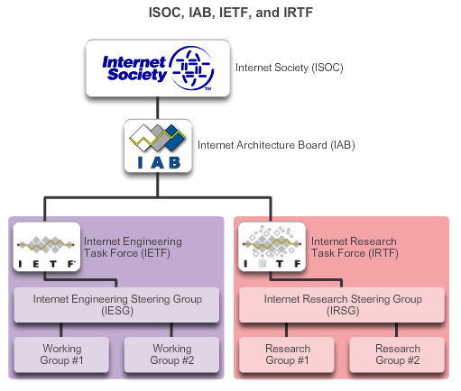

### 3.2.3.3 IEEE

I-triple-E

One of the leading standard producing organizations in the world

* IEEE 802 family -> local area networks and metropolitan area networks, wired as well as wireless

IEEE 802.3 = Media Access Control (MAC) for wired Ethernet -> LAN, also wide-area network (WAN)

IEEE 802.11: wireless local-area networks (WLANs) -> Open System Interconnection (OSi) physical and data link MAC for wireless communications

### 3.2.3.4 ISO

International Organization for Standardization -> world’s largest developer of international standards for a wide variety of products and services

* Of the Greek word: isos -> equal (to all countries)
* ISO best known for its Open System Interconnection (OSI) reference model
  + 1984: develop a layered framework for networking protocols intended to serve as a foundation for a suite of protocols used for the Internet (OSi protocol) -> TCP/IP suite was more popular and thus chosen. OSi protocol suite implemented on telecommunications equipment
* ISO file extension: ISO 9660

### 3.2.3.5 Other Standards Organizations

EIA: Electronics Industries Alliance AKA: Electronics Industries Association-> electrical wiring, connectors

TIA: Telecommunication Industry Association responsible for developing communication standards: radio equipment, cellular towers, voice over IP (VoIP) devices (skype) and satellite communication. Many of their standards in collaboration with EIA

ITU-T: International Telecommunication Union- Telecommunication Standardization Sector. One of the largest and oldest communication standard organizations. Defines standards for video compression, Internet Protocol Television (IPTV) and broadband communication -> digital subscriber line (DSL)

ICANN: Internet Corporation For Assigned Names and Numbers: non-profit, based in the US, coordinates IP address allocation, management of domain names used by DNS and the protocol identifiers or port numbers used by TCP and UDP protocols

IANA: Internet Assigned Numbers Authority, department of ICANN, responsible for overseeing and managing IP address allocation, domain name management, protocol identifiers for ICANN

## 3.2.4 Reference Models

### 3.2.4.1 The Benefits of Using a Layered Model

A layered model often used to help visualize the interaction between various protocols

Benefits:

* Assists in protocol design
* Fosters competition -> products from different vendors can work together
* Prevents technology of capability changes in one layer from affecting other layers
* Provides a common language to describe networking functions and capabilities

Two basic types of networking models:

* Protocol model: matches closely the structure of a particular protocol suite. TCP/IP model is a protocol model -> describes the functions that occur at each layer of protocols
* Reference model: Describes what has to be done at a particular layer, but not how it should be done. Reference model is not intended to be an implementation specification, primary objective: aid in clearer understanding of the functions and processes involved -> OSI models

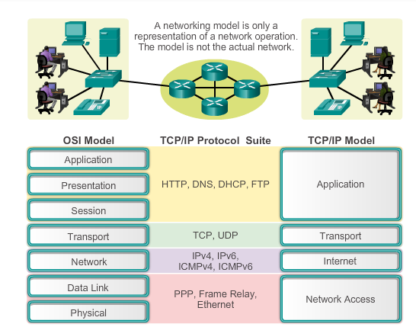

OSI model

1. Physical: describes the mechanical, electrical, functional and procedural means to activate, maintain and de-activate physical connections for bit transmission to and from a network device
2. Data link: Describes methods for exchanging data frames between devices over a common media
3. Network: Exchange the individual pieces of data over the network between identified end devices
4. Transport: Services to segment, transfer and reassemble data for individual communication
5. Session: Provides services to the presentation layer to organize its dialogue and to manage data exchange
6. Presentation: For common representations of the data transferred between application layer services
7. Application: provides the means for end-to-end connectivity

### 3.2.4.2 The TCP/IP Protocol Model

Referred to as the Internet model

Because it is open Standard, one vendor does not control the definition of the model

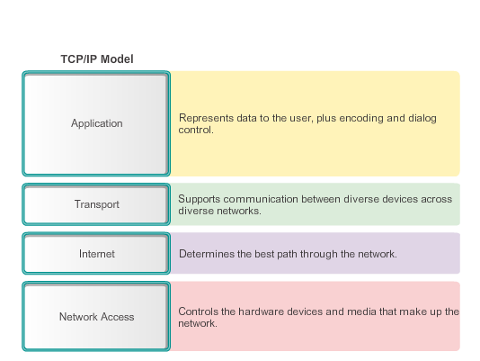

### 3.2.4.3 Comparing the OSI Model with the TCP/IP Model

Network access layer

* TCP/IP protocol suite does not specify which protocols to use when transmitting over a physical medium
* OSI layers 1 and 2 discuss the necessary procedures to access the media and the physical means to send data over a network

OSI layer 3: IP is the TCP/IP suite protocol that includes functionality described at OSI layer 3

OSI layer 4: Transport layer -> general services and functions that provide ordered and reliable delivery of data between source and destination host

* Acknowledgement, error recovery and sequencing
* TCP/IP: TCP and User Datagram Protocol (UDP) provide the necessary functionality

#### 3.2.4.3.1 Packet Tracer – Investigating the TCP/IP and OSI Models in Action

# 3.3 Moving Data in the Network

## 3.3.1 Data Encapsulation

### 3.3.1.1 Communicating the Messages

If everything was sent across a network as one big chunk of data, no other devices would be able to send or receive messages on the same network while this data transfer was in progress -> delays + if infrastructure would fail during transmission -> complete message lost

* Divide data into smaller pieces -> segmentation: benefits:
  + Many different conversations can be interleaved on the network. Process used to interleave the pieces of separate conversations together: multiplexing
  + Better reliability -> separate pieces do not need to travel the same path, only missing parts need to be retransmitted
* Downside:
  + Level of complexity -> time consuming to address, label, send, receive, open all the ‘frames’

Multiplexing: interleaving pieces of different senders, dividing bandwidth

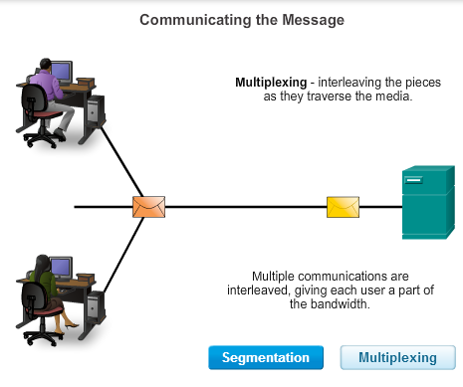

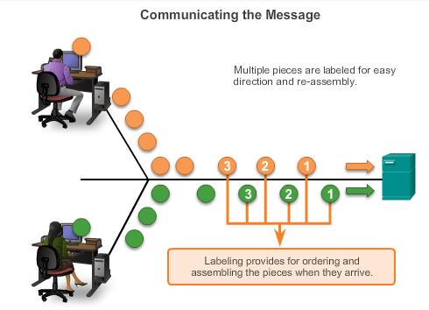

### 3.3.1.2 Protocol Data Units (PDUs)

Encapsulation process: as application data is passed down the protocol stack on its way to be transmitted across the network media, various protocols add information to it at each level

Form that a piece of data takes at any layer is called a protocol data unit (PDU)

* During encapsulation, each succeeding layer encapsulates the PDU that it receives from the layer above in accordance with the protocol being used
  + Data: general term for the PDU used at application layer
  + Segment: Transport layer PDU
  + Packet: Network layer PDU
  + Frame: Data Link Layer PDU
  + Bits: Physical layer PDU used when physically transmitting data over the medium

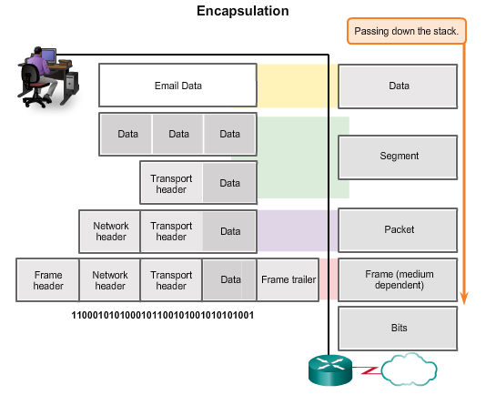

### 3.3.1.3 Encapsulation

Data encapsulation is the process that adds additional protocol header information to the data before transmission

* Example:
  + Application layer protocol, HTTP begins the process by delivering the HTML formatted web page data to the transport layer
  + There Application data is broken into TCP segments
  + Each TCP segment gets a label, called header containing info about which process running on the destination computer should receive the message + it contains info that enables the destination process to reassemble the data back into its original format
  + Transport layer encapsulates the webpage with a transport header and data send to Internet layer
  + IP protocol implemented -> IP header: source and destination host IP addresses + info necessary to deliver the packet to its corresponding destination process
  + IP packet sent to network access layer: encapsulated within a frame header and trailer. Frame header contains source and destination physical address
    - Physical address: uniquely identifies the devices on the local network
    - Trailer: error checking info
  + Bits encoded onto the media by the server network interface card (NIC)

### 3.3.1.4 De-encapsulation

Process reversed at receiving host -> removing one or more protocol headers

## 3.3.2 Accessing Local Resources

### 3.3.2.1 Network Addresses and Data Link addresses

Network layer and data link layer both responsible for delivering the data from the source device to the destination device

* Protocols at both layers contain source and destination addresses, but have different purposes

**Network Address**

Layer 3: logical address contains info required to deliver IP packet from the source device to the destination device

* IP address has 2 parts: network prefix and host part
  + Network prefix: used by routers to forward packet to the proper network
  + Host part: used by the last router in the path to deliver the packet to the destination device

**Data Link Address**

Layer 2: purpose of data link address is to deliver the data link frame from one network interface to another network interface on the same network

* Before an IP packet can be sent over a wired/wireless network it must be encapsulated in a data link frame so it can be transmitted over the physical medium
  + Ethernet LAN’s and wireless LAN’s are two examples of networks that have different physical media with its own type of data link protocol

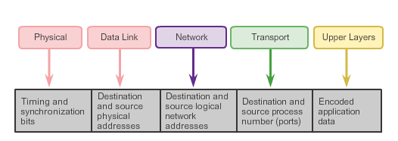

### 3.3.2.2 Communicating with a Device on the Same Network

**Data Link Addresses**

When sender and receiver of the IP packet are on the same network, data link frame is sent directly to the receiving device. On Ethernet, data link addresses are known as Ethernet MAC addresses

* 48-bit addresses that are physically embedded on the Ethernet NIC -> physical address or burned-in-address (BIA)

Look at the example

### 3.3.2.3 MAC and IP Addresses

Source host can learn the destination IP address in a number of ways

* Through DNS (Domain Name System)
* Address is entered in the application manually

Acquiring the MAC address of another device:

* Sending host uses a protocol called Address Resolution Protocol (ARP) to discover the MAC address of any host on the same local network -> to the entire LAN (broadcast message)
  + Contains IP address of destination device, if the correct pc receives the request it responds with an ARP reply with the MAC address
  + 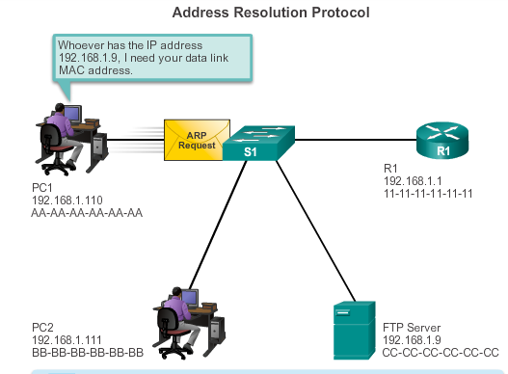
  + 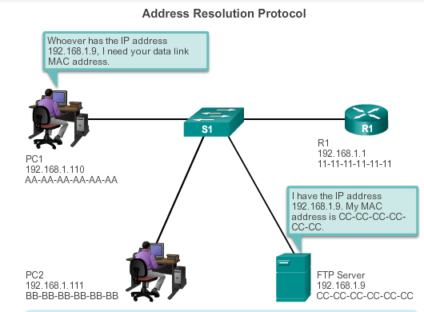

## 3.3.3 Accessing Remote Resources

### 3.3.3.1 Default Gateway

Method that a host uses to send messages to a destination on a remote network differs from the way a host sends messages to a destination on the same local network

* Same network: forward the request immediately
* Remote network: A router must be used -> default gateway
  + The default gateway is the IP address of an interface on a router on the same network as the sending host
  + Important that the address of the default gateway be configured on each host on the local network -> else it cannot be delivered

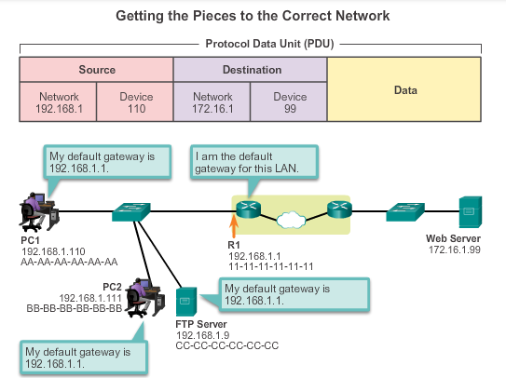

### 3.3.3.2 Communicating with a Device on a Remote Network

**Data Link Addresses**

Sender and receiver of the IP packet are on different networks -> Ethernet data link frame cannot be sent directly to the destination host -> not reachable

* Ethernet frame must be sent to router (default gateway)
* Etnernet MAC address is that of the default gateway

The host uses an ARP to determine the MAC address of that default gateway

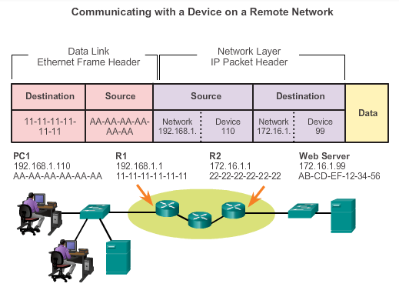

# 3.4 Summary

# 4.0 Network Access

## 4.0.1 Introduction

### 4.0.1.1 Introduction

Sending device, data link layer prepares data for transmission and control. The physical layer controls how the data is transmitted onto the physical media by encoding binary digit into signals

Receiving device, physical layer receives signals, after decoding signal back into data, physical layer passes the data to the link layer for acceptance and processing

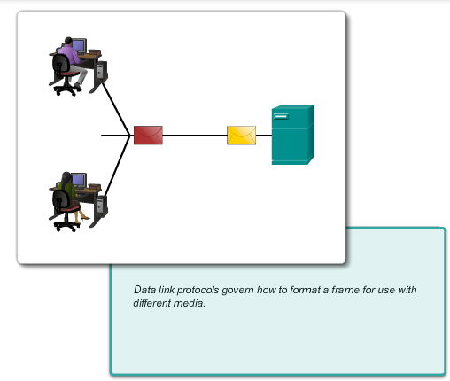

# 4.1 Physical Layer Protocols

## 4.1.1 Getting it Connected

### 4.1.1.1 Connecting to the Network

First: establish physical connection to a local network -> wired or wireless

* For wireless: network must have a wireless access point (WAP)

Switch and wireless access points are often two separate dedicated devices within a network implementation

* Devices with both wired and wireless connectivity-> home integrated service routers (ISRs)

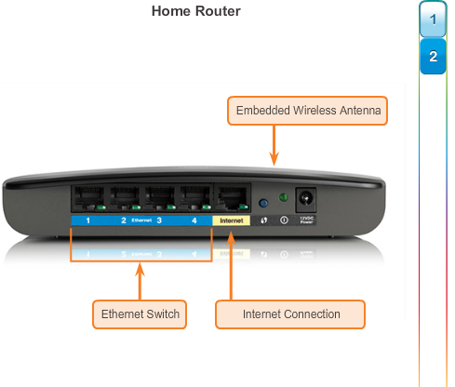

### 4.1.1.2 Network Interface Cards

Connect a device to the network, end-device has one or both

* Ethernet NIC’s used for wired connections
  + Does not degrade, but is extremely limited in movement
  + No sharing access -> separate communication channels -> good for online gaming
* WLAN (Wireless Local Area Network) NIC’s are used for wireless
  + Degradation in performance, based on distance to WAP -> wireless range extender regenerates the signal
  + Shared airwaves -> slower network if more devices access the network

## 4.1.2 Purpose of the Physical Layer

### 4.1.2.1 The Physical Layer

This layer accepts a complete frame from the data link layer and encodes it as a series of signals that are transmitted onto the local media.-> encoded bits are received by an end-device or intermediate device

Process that data undergoes from a source node to a destination node:

* User data segmented by transport layer, placed in packets by the network layer and further encapsulated as frames by the data link layer
* Physical layer encodes frames and creates electrical, optical or radio wave signals
* Signals sent on the media
* Destination node physical layer retrieves signals, restores to bits, bits go to data link layer as a complete frame

### 4.1.2.2 Physical Layer Media

Three basic forms of network media

* Copper cable: signals are patterns of electrical pulses
* Fiber-optic cable: signals are patterns of light
* Wireless: signals are patterns of microwave transmissions

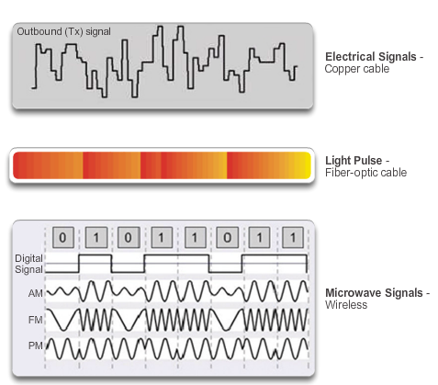

### 4.1.2.3 Physical Layer Standards

Physical layer hardware, media, encoding and signaling standards are defined and governed by the

* International Organization for Standardization (ISO)
* Telecommunications Industry Association/Electronic Industries Association (TIA/EIA)
* International Telecommunication Union (ITU)
* American National Standards Institute (ANSI)
* Institute of Electrical and Electronics Engineers (IEEE)
* National telecommunications -> Federal Communication Commission (FCC) in USA; European Telecommunications Standard Institute (ETSI)

In addition to these: regional cabling standards:

* CSA (Canadian Standards Association)
* CENELEC (European Committee for Electrotechnical Standardization)
* JSA/JIS (Japanese Standards Association)

## 4.1.3 Fundamental Principles of Layer 1

### 4.1.3.1 Physical Layer Fundamental Principles

**Physical Components**

Electronic hardware devices, media and other connectors tat transmit and carry signals to represent the bits

* Hardware components:
  + Network adapters (NICs), interfaces and connectors, cable materials, cable designs

**Encoding**

Line encoding is a method of converting a stream of data bits into a predefined “code”

* Codes are grouping of bits used to provide a predictable pattern recognized by both sender and receiver
* Codes for control purpose -> identifying beginning and end of frame

Common network encoding methods:

* Manchester encoding: -> used in older versions of Ethernet, RFID and Near Field communication
  + 0: high to low voltage transmission
  + 1: low to high voltage transmission
* Non-return to Zero (NRZ):
  + 0: one voltage level on the media
  + 1: different voltage level on the media

**Signaling**

This layer must generate electrical, optical or wireless signals that represent 1 or 0 on the media

* Method of representing the bits -> signaling method

Morse code in communication

Signals can be transmitted in one of two ways:

* Asynchronous: Transmitted without an associated clock, time spacing between block is arbitrary -> frames require start and stop indicator flags
* Synchronous: Data signals sent along with clock signal -> evenly spaced time -> bit time

Common method to send data: modulation techniques

* Modulation: process by which characteristics of one wave (the signal) modifies another wave (the carrier)
  + Frequency Modulation (FM): carrier frequency varies according with the signal
  + Amplitude modulation (AM): carrier amplitude varies in accordance with the signal
  + Pulse-coded modulation (PCM): analog signal (voice) is converted into a digital signal by sampling the signal’s amplitude and expressing different amplitudes as a binary number. Sampling rate must be at least twice the highest frequency (???)

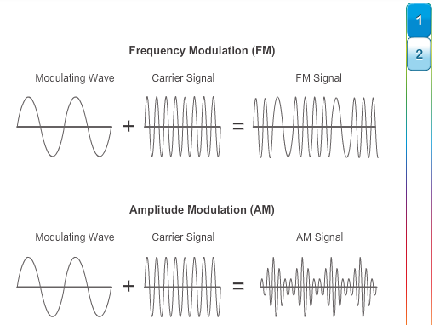

### 4.1.3.2 Bandwidth

Bandwidth: capacity of a medium to carry data. Digital bandwidth measures the amount of data that can flow from one place to another in a given amount of time

* Kilobits per second (kb/s) or megabits per second (Mb/s)

Practical bandwidth is determined by a combination of factors:

* Properties of the physical media
* Technologies chosen for signaling and detecting network signals

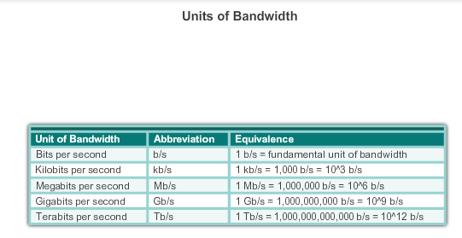

### 4.1.3.3 Throughput

Measure of the transfer of bits across the media over a given period of time

Due to a number of factors, throughput does not match bandwidth

* Amount of traffic
* Type of traffic
* Latency created by number of network devices encountered between source and destination (traveling time)

Througput cannot be faster than the slowest link of the path from source to destination

Goodput is the measure of usable data transferred over a given period of time

* Goodput = throughput – traffic overhead

### 4.1.3.4 Types of Physical Media

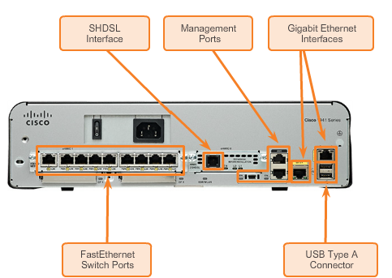

# 4.2 Network Media

## 4.2.1 Copper Cabling

### 4.2.1.1 Characteristics of Copper Media

Inexpensive, easy to install and has low resistance to electrical current

* But limited by distance and signal interference

Electrical pulses -> detector in network interface of destination device must receive the signal and decode it to the signal that was sent

* The longer a signal travels, the more it deteriorates -> signal attenuation

Timing and voltage values of electrical pulses are also susceptible to interference from two sources

* Electromagnetic interference (EMI) or radio frequency interference (RFI)
  + Radio waves and electromagnetic devices such as fluorescent lights or electric motors
  + Solution: wrapping in metallic shielding and proper grounding connections
* Crosstalk
  + Disturbance caused by the electric or magnetic fields of a signal on one wire to the signal in an adjacent wire
    - Telephone: hearing part of another voice conversation from an adjacent circuit
    - Solution: pairs twisted -> cancels crosstalk

Susceptibility of copper cables to electronic noise can also be limited by:

* Selecting cable type or category most suited to a given network environment
* Designing cable infrastructure to avoid known potential sources of interference
* Using cabling techniques that include the proper handling and termination of the cables

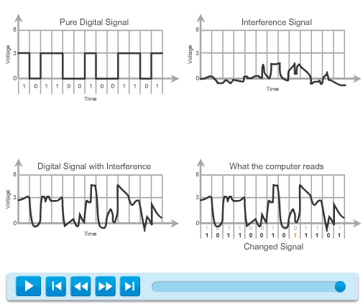

### 4.2.1.2 Copper Media

Three main types of copper media used in networking

* Unshielded Twisted-Pair (UTP)
* Shielded Twisted-Pair (STP)
* Coaxial

### 4.2.1.3 Unshielded Twisted-Pair Cable

Most common

Has a RJ-45 connector, used for interconnecting network hosts with intermediate network devices (switches and routers)

LAN

* Four pairs of color-coded wires that have been twisted together and then encased in a flexible plastic sheath

### 4.2.1.4 Shielded Twisted-Pair (STP) cable

More expensive and more difficult to install than UTP cabling

Terminated with a special shielded STP data connector

* If the cable is improperly grounded, shield may act like an antenna and pick up unwanted signals

Two common variations of STP:

* Shields the entire bundle of wires with foil -> more common
* Shields the entire bundle of wires + all the individual wire pairs

Can transport 10 GB

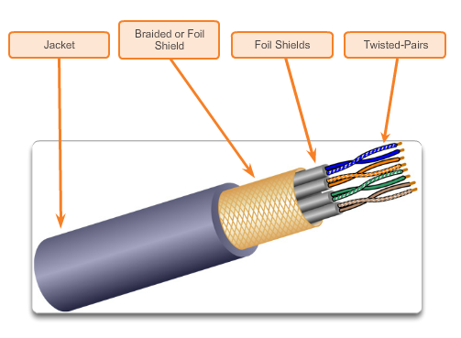

### 4.2.1.5 Coaxial Cable

There are two conductors that share the same axis

* Copper conductor -> transmit electronic signals
* Layer above the copper conductor: flexible plastic insulation
* Above is a woven copper braid or metallic foil that acts as the second wire in the circuit and as a shield for the inner conductor -> reduces amount of electromagnetic interference
* Last: cable jacket to protect from minor physical damage

Different types of connectors used with coax cable

UTP has replaced coaxial cable in modern Ethernet installations, but coax cable has been adapted for use in:

* Wireless installations: antennas to wireless devices with coax
* Cable internet installations: combination of fiber and coax -> hybrid fiber coax (HFC)

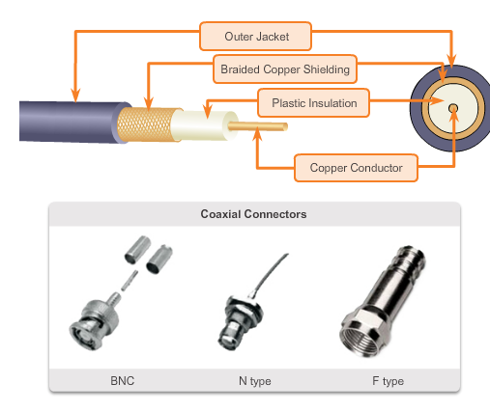

### 4.2.1.6 Copper Media Safety

Fire hazards: Cable insulation and sheaths may be flammable or produce toxic fumes when heated or burned

Electrical hazards:

* conducting electricity to chassis of stuff
* undesirable voltage levels when used to connect devices that have power sources with different ground potentials -> different buildings/floors
* lightning

## 4.2.2 UTP Cabling

### 4.2.2.1 Properties of UTP Cabling

4 pairs of color-coded wires that have been twisted and encased in a flexible plastic sheath

* has a diameter of 0.43 cm

Negative effect of crosstalk can be limited by:

* Cancellation: Two wires in an electrical circuit placed together have opposite magnetic fields
* Varying the number of twists per wire pair: each pair has a specified number of twists

### 4.2.2.2 UTP Cabling Standards

TIA/EIA-568A stipulates the commercial cabling standards

* Cable types
* Cable lengths
* Connectors
* Cable termination
* Methods of testing cable

3 Categories of UTP cabling

* Category 3:
  + Used for voice communication
  + Most often used for phone lines
* Category 5 and 5e:
  + Used for data transmission
  + Supports 100 Mb/s and can support 1000 Mb/s (not recommended)
  + 5e: supports 1000 Mb/s
* Category 6:
  + Data transmission
  + Separator between each pair -> higher speeds -> 1000 Mb/s – 10 Gb/s (not recommended)

### 4.2.2.3 UTP Connectors

ISO 8877 specified RJ-45 connector

TIA/EIA 568 standard describes the wire color codes to pin assignments

### 4.2.2.4 Types of UTP Cable

Different situations may require UTP cables to be wired according different wiring conventions -> individual wires have to be connected in different orders to different sets of pins in the RJ-45 connectors

Main cable types:

* Ethernet Straight-through: Most common -> interconnect host to switch and switch to router
* Ethernet Crossover: Uncommon -> interconnect similar devices together: switch – switch
* Rollover: Cisco proprietary cable used to connect to a router or switch console port

Using crossover or straight through incorrectly does not damage the device -> but no communication

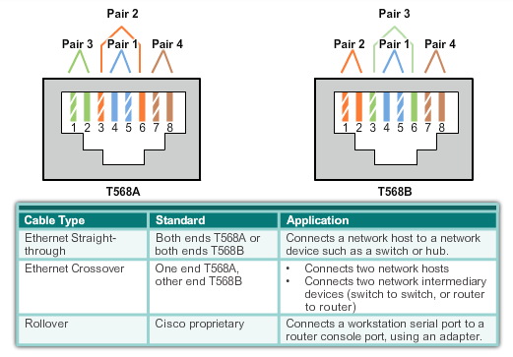

## 4.2.3 Fiber Optic Cabling

### 4.2.3.1 Properties of Fiber Optic Cabling

Very popular for interconnecting infrastructure network devices

* Data over longer distances and at higher bandwidths (data rates)

Optical fiber -> flexible but extremely thin transparent strand of pure glass (silica) -> human hair size

* Bits encoded as light impulses

Transmits signals with less attenuation and is completely immune to EMI RFI

Fiber-optic cabling is being used in four types of industry:

* Enterprise Networks: backbone cabling applications and interconnecting infrastructure devices
* FTTH and Access Networks: Fiber-to-the-Home
* Long-Haul networks: to connect countries and cities. Networks range form few dozen to few thousand km and use up to 10 Gb/s-based system
* Submarine Networks: Special fiber cables used to provide reliable high-speed, high-capacity

### 4.2.3.2 Fiber Media Cable Design

Optical fiber cable is composed out of:

* Core: pure glass, light is carried through
* Cladding: Glass that surrounds the core and acts like a mirror -> light stays in the core -> total internal reflection
* Jacket: PVC jacket that protects the core and cladding. May also include strengthening materials and a buffer (coating)

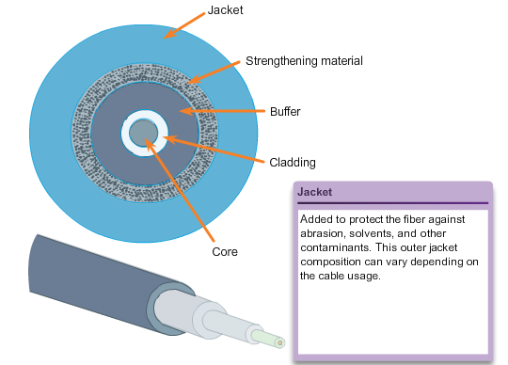

### 4.2.3.3 Types of Fiber Media

Light pulses generated by:

* Lasers -> can damage the human eye
* Light emitting diodes (LEDs)

Electronic semi-conductor devices (photodiodes) detect the light pulses and convert them to voltages that can be reconstructed into data frames

Fiber-optic cables can be classified into two types:

* Single-mode fiber (SMF): very small core, uses expensive laser technology, single ray
  + Popular in long-distance situations spanning hundreds of km (long haul and cable tv)
* Multimode fiber (MMF): larger core and uses LED at different angles
  + Popular in LAN’s -> low cost LEDs, 10 Gb/s up to 550 meters

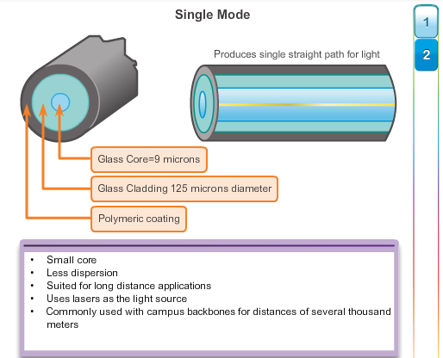

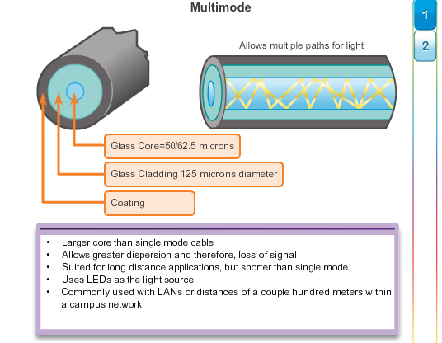

### 4.2.3.4 Network Fiber Connectors

Main difference among type of connectors are dimension and methods of mechanical coupling

Three most popular fiber-optic connectors:

* Straight-Tip (ST): older, used with multimode fiber
* Subscriber Connector (SC): Square connector/standard connector
  + Widely adopted LAN and WAN connector, uses push-pull, single and multimode fiber
* Lucent Connector (LC): little/local connector
  + Growing in popularity, single as well as multimode fiber

Ferrule Connector (FC) and Sub Miniature A (SMA) are not popular in LAN and WAN

Because light can only travel in one direction -> two fibers required

* Fiber-optic patch cables bundle two optical fiber cables and terminate with pair of standard single fiber connectors
  + SC-SC multimode
  + LC-LC single-mode
  + ST-LC multimode
  + SC-ST single-mode
* Other option is keeping them single

Cables with yellow -> single mode fiber

Cables with orange (or aqua) -> multimode fiber cables

### 4.2.3.5 Testing Fiber Cables

Three common types of fiber-optic termination and splicing errors:

* Misalignment: fiber-optic media are not precisely aligned when joined together
* End gap: media does not completely touch at the splice or connection
* End finish: Media ends are not well polished or dirt present at termination

Quick test: shine with a flashlight in the cable, light should come through

Recommended: optical tester (Optical Time Domain Reflectometer OTDR)

### 4.2.3.6 Fiber versus Copper

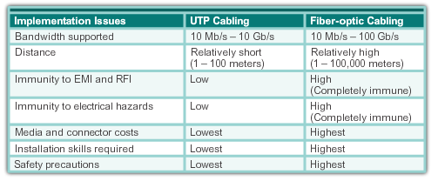

## 4.2.4 Wireless Media

### 4.2.4.1 Properties of Wireless Media

Uses radio or microwave frequencies

* Greatest mobility

Concerns:

* Coverage area: works well in open environments, but construction materials and the local terrain will limit the effective coverage
* Interference: can be disrupted by household cordless phones, fluorescent, microwave ovens
* Security: no access needed to physical strand of media

### 4.2.4.2 Types of Wireless Media

Three common data communications standards apply:

* Standard IEE 802.11: Wireless LAN (WLAN):Wi-Fi
  + Uses contention or non-deterministic system with a Carrier Sense Multiple Access/Collision
* Standard IEE 802.15: Wireless Personal Area Network (WPAN) -> Bluetooth
  + Distances: 1 to 100 meters
* Standard IEE 802.16: Worldwide Interoperability for Microwave Access (WiMAX)
  + Point-to-multipoint topology

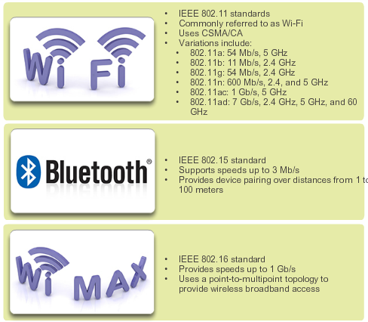

### 4.2.4.3 Wireless LAN

Requires the following network devices:

* Wireless Access Point (AP): Concentrate the wireless signals from users and connects – usually through a copper cable – to existing copper-based networks such as Ethernet
* Wireless NIC adapters: provide wireless communication capability to each network host

### 4.2.4.4 802.11 Wi-Fi Standards

Various standards:

* IEEE 802.11a: 5 GHz frequency band, speed up to 54 Mb/s
  + High frequency -> smaller coverage and less effective at penetrating buildings
  + Not interoperable with 802.11b and 802.11g
* IEEE 802.11b: 2.4 GHz frequency band, speed up to 11Mb/s
  + Longer range and better able to penetrate building structures
* IEEE 802.11g 2.4 GHz frequency band, speed up to 54 Mbs
* IEEE 802.11n 2.4 GHz or 5 GHz, speed from 150 Mb/s to 600 Mb/s
  + Distance: 70meters
  + Backwards compatible with a,b,g devices
* IEEE 802.ac: 5GHz frequency, speed from 450 Mb/s to 1.3Gb/s
  + Backwards compatible with a/n devices
* IEEE 802.ad -> WiGig, uses tri-band Wi-Fi solution using 2.4 GHz, 5GHz and 60 GHz
  + Speed: 7 Gb/s

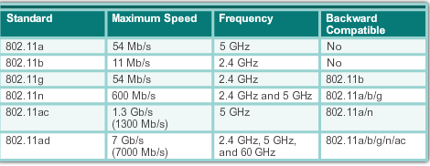

# 4.3 Data Link Layer Protocols

## 4.3.1 Purpose of the Data Link Layer

### 4.3.1.1 The Data Link Layer

Data link layer is responsible for the exchange of frames between nodes over a physical network media (Layer 2 notation for network devices connected to a common media: node)

These 2 basic services are performed:

* Accepts layer 3 packets and packages them into data units called frames
* Controls media access and performs error detection

### 4.3.1.2 Data Link Sublayers

Divided into two sublayers

* Logical Link Control (LLC): defines the software processes that provide services to the network layer protocols
  + Places information in the frame that identifies which network layer protocol is being used for the frame
  + Allows multiple layer 3 protocols to utilize the same network interface and media
* Media Access Control (MAC): defines the media access processes performed by the hardware
  + Provides data link layer addressing and delimiting data according to the physical signaling requirements of the medium and type of data link layer protocol

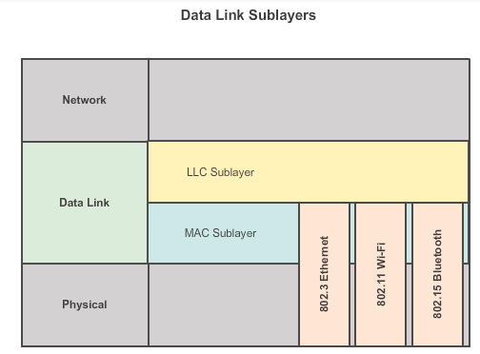

### 4.3.1.3 Media Access Control

Technique used for getting the frame on and off media = media access control method

* Without this network layer protocols such as IP would have to make provisions for connecting to every type of media that could exist along a delivery path

### 4.3.1.4 Providing Access to Media

Different media access control methods may be required during the course of a single communication

At each hop along the path, a router:

* Accepts a frame from a medium
* De-encapsulates the frame
* Re-encapsulates the packet into a new frame
* Forwards the new frame appropriate to the medium of that segment of the physical network

## 4.3.2 Layer 2: Frame structure

### 4.3.2.1 Formatting Data for Transmission

Description of frame is key element of each data link layer protocol

Data link layer protocols require control information to enable the protocols to function. These protocols answer:

* Which nodes are in communication with each other
* When does communication between individual nodes begin and end?
* Which errors occurred while communication?
* Which nodes will communicate next?

Data link layer frame includes:

* Header: control info: addressing, located beginning PDU
* Data: IP header, transport layer header, application data
* Trailer: Contains info for error detection

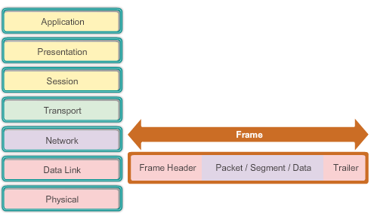

### 4.3.2.2 Creating a Frame

Framing breaks the stream into decipherable groupings, with control information inserted in the header and trailer

Generic frame fields:

* Frame start and stop indicator flags: used by MAC sublayer to identify beginning and end of frame
* Addressing: Used by MAC sublayer to identify the source and destination nodes
* Type: used by LLC to identify Layer 3 Protocol
* Control: Identifies special flow control services
* Data: Contains frame payload (packet header, segment header, data)
* Error Detection: Included after the data to form the trailer

Not all protocols include all of these fields

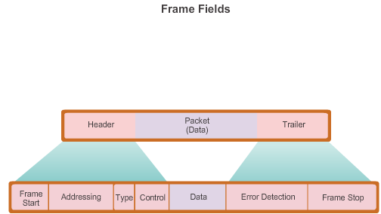

## 4.3.3 Layer 2 Standards

### 4.3.3.1 Data Link Layer Standards

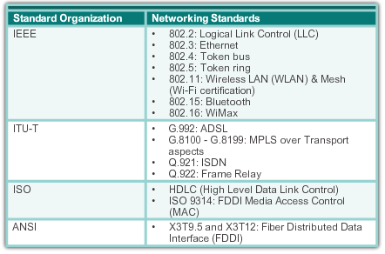

# 4.4 Media Access Control

## 4.4.1 Topologies

### 4.4.1.1 Controlling Access to the Media

Equivalent of traffic rules that regulate the entrance of motor vehicles onto a roadway

* Different ways to regulate placing frames onto the media

The actual media access control method used depends on:

* Topology: How the connection between the nodes appears to the data link layer
* Media Sharing: How the nodes share the media, point-to-point (WAN) or shared (LAN)

### 4.4.1.2 Physical and Logical Topologies

Two ways:

* Physical topology: Identifies how end devices and infrastructure devices are interconnected
* Logical topology: The way a network transfers frames from one node to the next

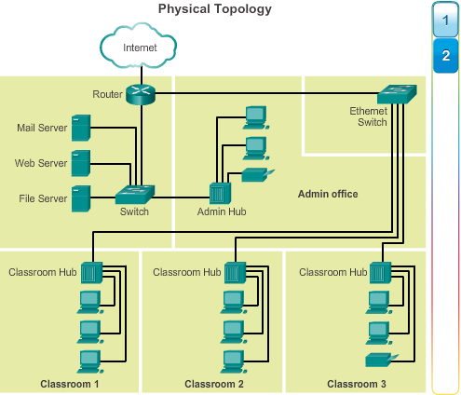

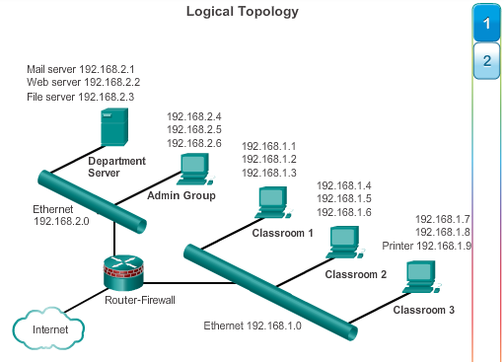

## 4.4.2 WAN Topologies

### 4.4.2.1 Common Physical WAN Topologies

Interconnected using the following topologies:

* Point-to-Point: simplest topology -> permanent link between two endpoints
* Hub and Spoke: WAN version of the star topology
* Mesh: Provides high availability, but requires that every end system be interconnected to every other system
  + High administrative and physical costs

### 4.4.2.2 Physical Point-to-Point Topology

No sharing + a node does not have to make any determination about whether an incoming frame is destined for it or another node

### 4.4.2.3 Logical Point-to-Point Topology

Source and destination node may be indirectly connected to each other over some geographical distance

* Logical connections between nodes can form a virtual circuit: logical connection created within a network between two network devices

Media access method used by data link protocol is determined by the logical point-to-point topology

### 4.4.2.4 Half and Full Duplex

Data can flow in one of two ways:

* Half-duplex communication: both devices can transmit and receive data, but not simultaneously
* Full-duplex: Both devices can transmit and receive at the same time

## 4.4.3 LAN Topologies

### 4.4.3.1 Physical LAN Topologies

Physical Topologies:

* Star: End-devices connected to a central intermediate device
  + Early star: using hubs, now switches
  + Most common -> easy to install, very scalable and easy to troubleshoot
* Extended star or hybrid: extended star, central intermediate devices interconnect other stars
  + Hybrid topology: star networks may interconnect using bus
* Bus: all end systems chained to each other and terminate in some form on each end
  + Infrastructure devices (switches) not required to interconnect end-devices
* Ring: Fiber Distributed Data Interface (FDDI) networks
  + FDDI networks employ a second ring for fault tolerance or performance enhancements

### 4.4.3.2 Logical Topology for Shared Media

Two basic media access control methods for shared media

* Contention-based access: All nodes compete for the use of the medium, but have a plan if there are collisions
* Controlled access: each node has its own time to use the medium

### 4.4.3.3 Contention-Based Access

Non-deterministic contention-based method: device can attempt to access the medium whenever it has data

* To prevent chaos: Carrier Sense Multiple Access (CSMA): detects if the media is carrying a signal
  + Ethernet and wireless
* If collision: both data has to be resent

CSMA usually implemented in conjunction with a method for resolving the media contention. Two commonly used methods:

* Carrier sense multiple access with collision detection (CSMA/CD)
* Carrier sense multiple access with collision avoidance (CSMA/CA): if the medium is free it will send a notification -> once it receives clearance, then it will send

### 4.4.3.4 Multi-Access Topology

Every node sees all the frames that are on the medium, but only the node where the frame is addressed to processes the contents of the frame

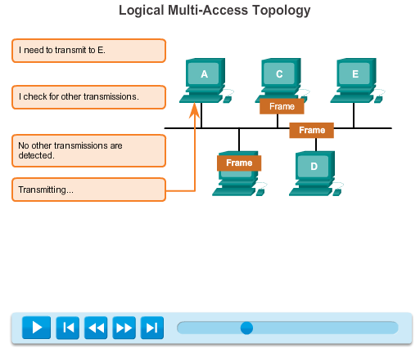

### 4.4.3.5 Controlled Access

Network devices take turns -> facilitated by use of a token

* Scheduled access or deterministic

Controlled Access examples -> both unmodern

* Token Ring (802.5)
* Fiber Distributed Data Interface (FDDI) based on IEEE 802.4 token bus protocol

### 4.4.3.6 Ring Topology

Each node in turn receives a frame, if its not for him, it will be passed on to the next node -> token passing

## 4.4.4 Data Link Frame

### 4.4.4.1 The frame

Each frame type has 3 basic parts:

* Header
* Data
* Trailer

Data link layer protocol describes the features required for the transport of packets across different media

Amount of control information needed in the frame varies to match the media access control requirements

### 4.4.4.2 The header

Contains the control info specified by the data link layer protocol for the specific logical topology and media used

Ethernet frame header fields:

* Start Frame field: indicates the beginning of the frame
* Source and Destination Address fields: Indicates the source and destination nodes on the media
* Type field: Indicates the upper layer service contained in the frame

Other Layer 2 protocol header frame fields could include:

* Priority/Quality of Service Field: indicates a particular type of communication service for processing
* Logical connection control field: used to establish a logical connection between nodes
* Physical Link control field: used to establish media link
* Flow control field: Used to start and stop traffic over the media
* Congestion control field: Indicates congestion in the media

### 4.4.4.3 Layer 2 Address

Device addresses at this layer are referred to as physical addresses

* Physical addresses do not indicate on what network the device is located
  + Cannot be used to locate device across large networks -> used to locate device within a limited area

### 4.4.4.4 The Trailer

Used to determine if the frame arrived without error -> error detection

Transmitting node creates a logical summary of the contents of the frame -> cyclic redundancy check (CRC) value

* Value placed in the Frame Check Sequence (FCS)

When the frame arrives at the destination node, receiving node calculates its own logical summary (CRC)

* Compares the two CRC values
  + If same = no errors
  + Else frame is discarded

Small possibility that frame with good CRC is actually corrupt -> Upper layer protocols required to detect and correct

### 4.4.4.5 LAN and WAN frames

LAN uses high bandwidth technology that is capable of supporting a large number of hosts

* Small geographic area and its high density of users make this technology cost effective

Using a high bandwidth technology is usually not cost-effective for WANs that cover large geographic areas -> cost results in lower bandwidth capacity

Difference in bandwidth results in the use of different protocols for LANs and WANs

### 4.4.4.6 Ethernet Frame

**Ethernet**

Dominant LAN technology -> IEEE 802.2 and IEEE 802.3

* Unacknowledged connectionless service over a shared media using CSMA/CD as the media access method

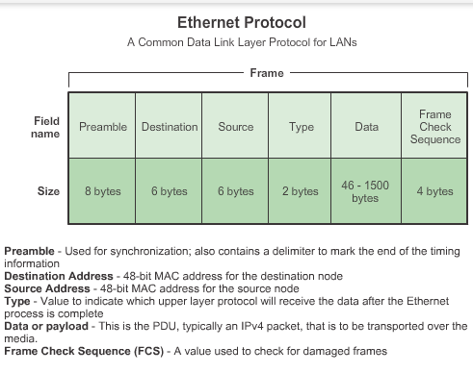

### 4.4.4.7 PPP Frame

**Point-to-Point Protocol**

PPP standard defined by RFC, developed as a WAN protocol and still is the protocol of choice

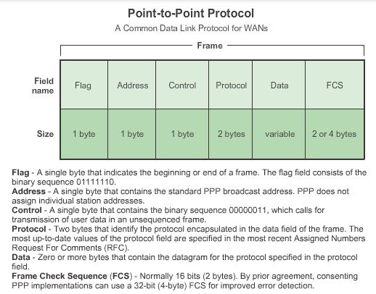

### 4.4.4.8 802.11 Wireless Frame

**802.11 Wireless**

Uses the same 802.2 LLC and 48-bit addressing scheme as other 802 LANs

* But many differences at the MAC sublayer and the physical layer -> additional controls
* Contention-based using CSMA/CA media access process
* Uses data link acknowledgements to confirm that a frame is received

Frame contains these fields:

* Protocol Version field: version of 802.11 frame in use
* Type and Subtype fields: identifies one of three functions and sub functions of the frame: control, data and management
* To DS field: set to 1 in data frames exiting the distribution system
* More Fragments field: set to 1 for frames that have another fragment
* Retry field: Set to 1 if the frame is a transmission of an earlier frame
* Power Management field: set to 1 indicate that a node will be in power-save mode
* More data field: set to 1 to indicate to a node in power-save mode that more frames are buffered for that node
* Wired Equivalent Privacy (WEP) field: set to 1 if the frame contains WEP encrypted info for security
* Order field: set to 1 in a data type frame that uses Strictly ordered service class
* Duration/ID field: depending on the type of frame, represents either the time required to transmit the frame or an association identity (AID) for the station that transmitted the frame
* Destination Address (DA) field: MAC address of the final destination node
* Source Address (SA) field: MAC address of the sender node
* Receiver Address (RA) field: MAC address that identifies the wireless device that is the immediate recipient of the frame
* Fragment Number field: Indicates the number for each fragment of frame
* Sequence number field: Indicates the sequence number assigned to the frame, retransmitted frames: duplicate sequence numbers
* Transmitter Address (TA) field: MAC address that identifies the wireless device that transmitted the frame
* Frame Body field: Contains the info being transported, IP packet
* FCS field: 32-bit cyclic redundancy check (CRC)

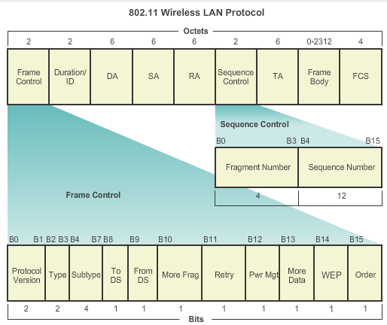

# 4.5 Summary

## 4.5.1 Summary

Cisco Chapter 5

# 5.0 Ethernet

## 5.0.1 Introduction

### 5.0.1.1 Introduction

Ethernet operates in data link layer and physical layer

# 5.1 Ethernet Protocol

## 5.1.1 Ethernet Operation

### 5.1.1.1 LLC and MAC Sublayer

IEEE 802.2 and IEEE 802.3

Bandwidth of: 10Mb/s – 100.000 Mb/s

Ethernet relies on two separate sublayers of the data link layer

* Logical Link Control (LLC)
* MAC sublayers

**LLC sublayer**

Communication between upper layers and lower layers -> between network software and device hardware

Implemented in software and is independent of the hardware

**MAC sublayer**

MAC implemented by hardware (in the pc NIC).

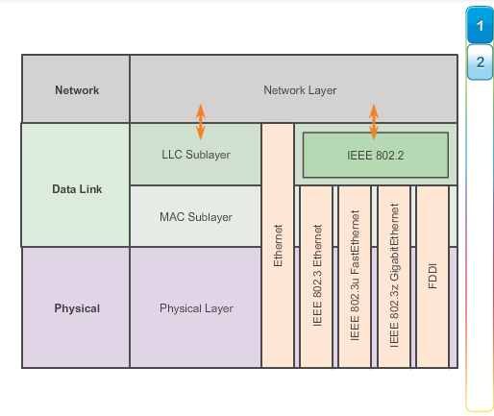

### 5.1.1.2 MAC Sublayer

MAC has two primary responsibilities:

* Data encapsulation
* Media access control

**Data encapsulation**

Three primary functions of data encapsulation

* Frame delimiting: Important delimiters used to identify a group of bits that make up a frame
* Addressing: Physical address (MAC address) in frame
* Error detection: trailer with cyclic redundancy check (CRC), receiving node creates a CRC to compare with the initial CRC

**Media Access Control**

Responsible for placement of frames on the media and the removal of frames from the media

Underlying logical topology of Ethernet is a multi-access bus -> devices on a single network segment share the medium

* Ethernet is contention-based medium -> Carrier Sense Multiple Access (CSMA) technology

### 5.1.1.3 Media Access Control

CSMA -> used to detect if medium is carrying a signal -> try again later

* Possibility that CSMA fails -> data collision -> resending

Does not scale well under heavy media use -> chances of collision increase

CSMA implemented in conjunction with resolving media contention

**CSMA/Collision Detection**

Check if medium is free -> if not wait

* If fail: try stop immediately and resent

Traditional forms of Ethernet

Now: Almost all wired connections between devices in LAN are full-duplex -> sending and receiving simultaneously

* Collisions do not occur and processes utilized by CSMA/CD unnecessary

Wireless: still has to take collisions into account! But they use CSMA/Collision Avoidance (CSMA/CA)

### 5.1.1.4 MAC Address: Ethernet Identity

All nodes receive all frames that have been transmitted -> how can each device identify if it is the intended receiver? -> MAC address

* 48-bit expressed as 12 hexadecimal digits

**MAC Address Structure**

Global unique -> IEEE enforced rules for vendors

* Vendors must register with IEEE and the IEEE assigns the vendor a 3-byte (24 bit) code, called the Organizationally Unique Identifier (OUI)

Rules of IEEE to vendors:

* All MAC addresses assigned to a NIC must use that vendor’s assigned OUI as the first 3 bytes
* All MAC addresses with the same OUI must be assigned a unique value (vendor code in the last 3 bytes)

### 5.1.1.5 Frame Processing

MAC address = burned-in address (BIA) -> historically burned into ROM (Read-Only-Memory) on the NIC

* Cannot be changed by software
* But on modern PC operating systems and NIC’s it is possible to change MAC address in software -> filtering on MAC address is no longer as secure

Different hardware and software manufacturers might represent MAC address in different hexadecimal formats

* 00-05-9A-3C-78-00
* 00:05:9A:3C:78:00
* 0005.9A3C.7800

When computer starts up -> NIC copies MAC address from ROM into RAM

Each NIC in the network views information to see if destination MAC address in the frame matches the device physical MAC address stored in RAM -> else discard the frame

## 5.1.2 Ethernet Frame Attributes

### 5.1.2.1 Ethernet Encapsulation

Data link layer -> frame structure is nearly identical for all speeds of Ethernet

Section of frame = field

2 styles of Ethernet framing:

* 802.3: Ethernet standard which has been updated several times to include new technologies
* DIX Ethernet standard -> Ethernet II -> used in TCP/IP networks

Most significant difference between both: addition of Start Frame Delimiter (SFD) and the change of the Type field into Length field in 802.3

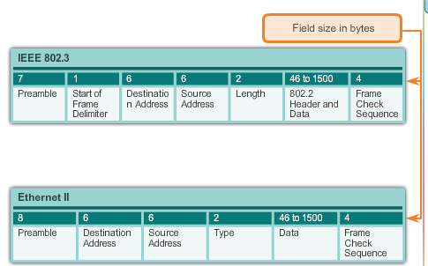

## 5.1.2.2 Ethernet Frame Size

Both Ethernet II and IEEE 802.3 define frame size as 64 bytes and max as 1518 bytes -> everything besides the preamble and frame delimiter

* Frames less than 64 bytes -> collision fragment/runt frame -> discarded

802.3ac extended max frame size to 1522 bytes -> to accommodate Virtual Local Area Network

* Many quality of service technologies leverage the user priority field to implement various levels of service
* 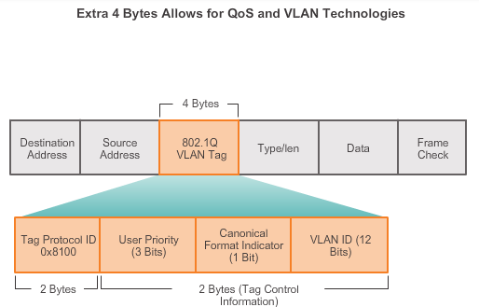

### 5.1.2.3 Introduction to the Ethernet Frame

**Preamble and start Frame Delimiter fields:** Used for synchronization between sending and receiving devices -> tells the receiving device to get ready

**Destination MAC Address Field:** Identifier for the intended recipient

**Source MAC Address Field:** Identifies the frame’s originating NIC or interface

**Length Field:** IEEE 802.3 earlier than 1997 -> length of frame’s data field, used in FCS to ensure that the message was received properly

* Otherwise: field describes which higher layer protocol is present
* Length groter dan of gelijk aan 0x0600/1536 -> contents of data field decoded according to EtherType protocol
  + Length even groot of kleiner dan 0x05DC/1500 -> IEEE 802.3

**Data Field:** encapsulated data from higher layer (layer 3).

* If packet is smaller than minimum -> additional bits added (pad)

**Frame Check Sequence Field:** Used to detect errors in a frame

* Uses cyclic redundancy check (CRC) -> receiving device recalculates and compares

## 5.1.3 Ethernet MAC

### 5.1.3.1 MAC Addresses and Hexadecimal

**Representing Hexadecimal Values**

In Text hexadecimal starts with 0x or subscript 16 or followed by H

### 5.1.3.2 MAC Address Representations

On Windows -> ipconfig/all command used to identify the MAC address

* Different notations

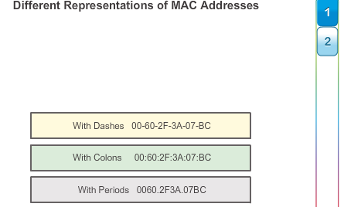

### 5.1.3.3 Unicast MAC Address

Different MAC addresses used for unicast, broadcast and multicast

* Unicast: unique address

### 5.1.3.4 Broadcast MAC Address

Broadcast packet contains destination IP address that has all ones (1s) in the host portion

* All hosts on local network will receive and process the packet
* ARP

### 5.1.3.5 Multicast MAC Address

Devices that belong to a multicast group get a multicast group IP address

* Range of IPV4 multicast addresses -> 224.0.0.0 to 239.255.255.255
* Source will always have a unicast address

Remote gaming

Multicast MAC address is a special value that begins with 01-00-5E, the remaining portion of the multicast MAC address is created by converting the lower 23 bits of the IP multicast group address into 6 hexadecimal characters

## 5.1.4 MAC and IP

### 5.1.4.1 MAC and IP

Two primary addresses assigned to a host device

* Physical address (MAC)
* Logical address (IP)

Analogy with person and where he/she lives

* MAC = person
* IP = address where he/she lives -> can change
  + Using this address it is possible for a frame to determine the location of where the frame should be sent

### 5.1.4.2 End-to-End Connectivity, MAC and IP

Most common way of a source device to determine the IP address of a destination device -> Domain Name Service (DNS) -> IP address associated with domain name

IP packet is encapsulated in a frame specific to data link technology

* Ethernet network does not accept and process frames based on IP addresses -> uses MAC

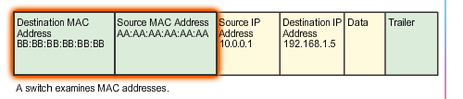

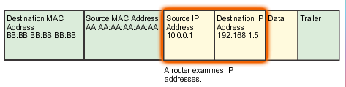

# 5.2 Address Resolution Protocol

## 5.2.1 ARP

### 5.2.1.1 Introduction to ARP

Sending node needs a way to find the MAC address of the destination for a given Ethernet Link -> ARP

ARP relies on certain types of Ethernet Broadcast messages and Ethernet Unicast messages -> ARP requests and ARP replies

Two basic ARP functions:

* Resolving IPv4 addresses to MAC addresses
* Maintaining a table of mappings

### 5.2.1.2 ARP Functions

**Resolving IPv4 Addresses to MAC Addresses**

ARP table/ARP cache -> needed to find the data link layer address that is mapped to the destination IPv4 address

* Stored in RAM of device

**Maintaining the ARP Table**

Two ways device can gather MAC addresses

* Monitor traffic that occurs -> receiving frames and recording source IP and MAC address
* ARP request -> broadcast

If a device does not receive a frame from a particular device by the time the time expires -> device removed from ARP table

Static map entries -> need to be manually removed (technique rarely used)

### 5.2.1.3 ARP Operation

If the node does not contain a map of an IP address to a destination MAC address -> generating ARP request

* If no device responds to the ARP request, packet is dropped, encapsulation failure reported to upper layers
  + If this device is an intermediate device (router) upper layers may choose to respond to the source host with an error in ICMPv4 packet

### 5.2.1.4 ARP Role in Remote communication

Destination not local network -> MAC of default gateway

* Not in table -> ARP request

### 5.2.1.5 Removing Entries from an ARP table

ARP cache timer removes ARP entries that have not been used for a specific period of time

* Time differs depending on the device and its operating system -> Windows during 2 minutes, if used then extended for 10 minutes

Commands may also be used to manually remove all or some of the entries

* Commands depends on operating system

### 5.2.1.6 ARP Tables on Networking Devices

Cisco router: show ip arp -> arp table

On windows 7: arp –a

## 5.2.2 ARP Issues

### 5.2.2.1 How ARP Can Create Problems

**Overhead on the Media**

If all students in a lab logged into classrooms computers and attemted to access the Internet at the same time -> delays

* After that devices learned the necessary MAC address, any impact on the network will be minimized

**Security**

In some cases potential security risk -> ARP spoofing or ARP poisoning

* Attacker injects the wrong MAC address associated into a network by issuing fake ARP replies

Defense: Manually configuring static ARP associations and/or Authorized MAC addresses

### 5.2.2.2 Mitigating ARP Problems

With modern switches -> security technologies

Switches provide segmentation of LAN, deviding LAN into independent collision domains

* Each port on switch is a separate collision domain and provides full media bandwidth to node or nodes connected to that port

Security on switches: specialized access lists and port security

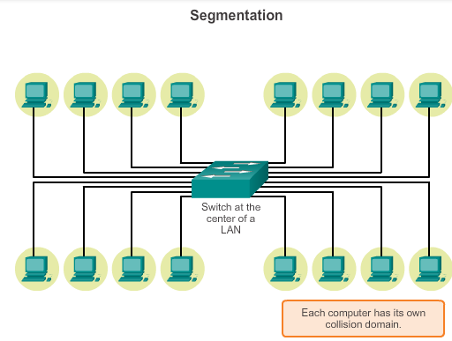

# 5.3 LAN Switches

## 5.3.1 Switching

### 5.3.1.1 Switch Port Fundamentals

Logical topology Ethernet: multi-access bus

Physical topology Ethernet: star or extended star -> point-to-point connection to a Switch

* Performs switching and filtering based only on the OSI data link layer MAC addressing

### 5.3.1.2 Switch MAC Address Table

When incoming data frame is received and the destination MAC address is not in the table, the frame is forwarded out al ports, except for the port where it was received -> gets MAC address that way

### 5.3.1.3 Duplex Settings

Switches can operate in different modes that can have both positive and negative effects when forwarding frames on a network

* Most basic: duplex setting of each individual port connected to each host device (must match the media type)

**Half Duplex**

Unidirectional data flow, sending/receiving not at the same time

CSMA/CD

Older hardware (hubs)

**Full Duplex**

Bidirectionele dataflow

Most Etherner, Fast Ethernet and Gigabit Ethernet NICs offer full-duplex

Collision detect circuit disabled

Cisco switch has an auto option -> autonegotiation -> 2 ports communicate to decide the best mode of operation

### 5.3.1.4 Auto-MDIX

It is also necessary to have the correct cable type defined for each port

* Most switches support now the mdix auto interface configuration command in the CLI to enable the automatic medium-dependent interface crossover (auto-MDIX)
  + Switch detects the required cable type for copper Ethernet connections and configures the interfaces accordingly -> does not matter if you use straight-through or crossover

### 5.3.1.5 Frame Forwarding Methods on Cisco Switches

In the past:

* Store-and-forward switching
  + Switches store data of frame in buffer until whole frame is received, during storage the switch analyzes the frame for a destination and performs an errorchecking (Cyclic Redundancy Check (CRC), if the check went ok, data is sent forward through the correct port
    - Else: data is discarded -> reduces bandwidth consummation -> required for Quality of Service (QoS)
* Cut-through switching

### 5.3.1.6 Cut-Through Switching

Switch acts upon the data as soon as it is received, even if transmission is not complete

* Just enough buffering to read destination MAC (first 6 bytes) after the preamble
* Then the switch looks the destination MAC address up in its switching table and determines the outgoing interface port and forwards
* No error checking -> corrupt frames consume bandwidth

Two variants of cut-through switching:

* Fast-Forward switching: lowest level of latency fist bit received to the first bit transmitted)
* Fragment-free-switching: Switch stores the first 64 bytes before forwarding -> compromise between store-and forward switching and fast-forward switching -> only the first 64 bytes since most network errors and collisions occur during the first 64 bytes -> small error check

Some switches are configured to perform cut-through switching on a per-port basis, until a user defined error threshold is reached -> automatic change to store-and-forward, after the rate falls below threshold, it changes back

### 5.3.1.8 Memory Buffering on Switches

Two methods of memory buffering: port-based and shared memory

**Port-based Memory Buffering**

Frames stored in queues that are linked to specific incoming and outgoing ports

* Frame is only transmitted to outgoing port if all the frames ahead of it in the queue have been successfully transmitted

**Shared Memory Buffering**

All frames into a common memory buffer that all the ports on a switch share

* Permits larger frames with fewer dropped frames -> important in asymmetric switching

## 5.3.2 Fixed or Modular

### 5.3.2.1 Fixed versus Modular Configuration

Power over Ethernet (PoE) = allows a switch to deliver power to a device, such as IP phones and some wireless access points -> flexibility for installation

Forwarding rate = processing capabilities of a switch -> how much data a switch can process per second

* Entry-layer switches: lower forwarding rates than enterprise-layer switches

Switch form factors:

* Stackable vs non-stackable
* Thickness of switch -> number of rack units
* Port density

**Fixed Configuration Switches**

No features or options can be added beyond the ones that came with the switch

**Modular Switches**

Different sized chassis -> installation of different numbers of modular line cards

Line cards contain the ports

### 5.3.2.2 Module Options for Cisco Switch Slots

Commercieel

## 5.3.3 Layer 3 Switching

### 5.3.3.1 Layer 2 versus Layer 3 Switching

Layer 2 switch performs switching and filtering based only on the OSI data link layer MAC address and depends on routers to pass the data between independent IP subnetworks

* Layer 3 functions similar, but it can also use IP address info –> learn which IP addresses associated with its interfaces
  + Also capable of performing layer 3 routing functions (same speed as router)

### 5.3.3.2 Cisco Express Forwarding

Cisco Devices which support Layer 3 switching use Cisco Express Forwarding (CEF)

* Decouples the strict interdependence between Layer 2 and layer 3 decision making
  + Forwarding IP packets can be slow -> referencing back-and-forth between Layer 2 and Layer3

Main components of CEF:

* Forwarding Information Base (FIB) -> similar to routing table -> optimized
* Adjacency Tables: maintain Layer 2 next-hop addresses

### 5.3.3.3 Types of Layer 3 Interfaces

Major types of Layer 3 interfaces are:

* Switch Virtual Interface (SVI): Logical interface on a switch associated with a virtual local network (VLAN)
* Routed port: Physical port on Layer 3 switch configured to act as a router port
* Layer 3 EthernetChannel: Logical interface on a Cisco device associated with a bundle of routed ports

### 5.3.3.4 Configuring a Routed Port on a Layer 3 Switch

Routed port:

* Is not associated with a particular VLAN
* Can be configured with a Layer 3 routing protocol
* Is a Layer 3 Interface only and does not support Layer 2 protocol

# 6.0 Network Layer

## 6.0.1 Introduction

### 6.0.1.1 Introduction

# 6.1 Network Layer Protocols

## 6.1.1 Network Layer in Communication

### 6.1.1.1 The Network Layer

OSI Layer 3, uses four basic processes:

* Addressing end devices: end devices must be configures with unique IP address for identification on the network ->host
* Encapsulation: receives protocol data unit form transport layer, adds IP header information, PDU is now called a packet
* Routing: role of router is to select paths for and direct packets toward destination host -> routing, each route the packet takes to reach the destination host is called a hop
* De-encapsulation: when destination IP address matches own IP address, IP header removed

### 6.1.1.2 Network Layer Protocols

Most commonly used:

* Internet Protocol version 4 (IPv4)
* Internet Protocol version 6 (IPv6)

## 6.1.2 Characteristics of the IP protocol

### 6.1.2.1 Characteristics of IP

IP is the network layer service implemented by the TCP/IP protocol suite

IP designed as a protocol with low overhead, basic characteristics of IP:

* Connectionless: No connection with the destination is established before sending data packets
* Best effort (unreliable): Packet delivery is not guaranteed
* Media Independent: Operation is independent of the medium carrying the data

### 6.1.2.2 IP – Connectionless

Similar to sending a letter without notifying the recipient in advance

### 6.1.2.3 IP – Best Effort Delivery

It does not have the capability to manage and recover from undelivered or corrupt packets -> no synchronization data included

If out-of-order or missing packets create problems for the application using the data, then upper layer services such as TCP must resolve these issues

### 6.1.2.4 IP – Media Independent

It is the responsibility of the OSI data link layer to take an IP packet and prepare it for transmission over the communications medium

* One major characteristic of the media that the network layer considers: the maximum size of the PDU that each medium can transport (Maximum Transmission Unit (MTU))
  + Data link layer passes the MTU value up to the network layer
  + In some cases, an intermediate device, usually a router, must split a packet when forwarding it from one medium with a smaller MTU -> fragmenting/fragmentation

### 6.1.2.5 Encapsulating IP

Process of encapsulating data layer by layer enables services at different layers to develop and scale without affecting other layers

## 6.1.3 IPv4 Packet

### 6.1.3.1 IPv4 Packet Header

Two parts:

* IP header: Identifies the packet characteristics
* Payload: Contains Layer 4 segment information and the actual data

Significant fields in the IPv4 header:

* Version – 4-bit binary value -> IP packet version (for IPv4 it is 0100)
* Differentiated Services (DS) -> Formerly called the Type of Service (ToS) field, used to determine the priority of each packet
  + First 6 bits identify the Differentiated Services Code Point used by QoS (Quality of Service)
  + Last 2 bits identify the explicit congestion notification (ECN) that can be used to prevent dropped packets during times of network congestion
* Time-to-Live(TTL): 8 bit used to limit the lifetime of a packet, specified in seconds (but referred to as hop count)
  + Sender sets a initial ttl and each time the packet is processed by a router, or hip, the value is decreased, if the time runs out, the router discards the packet and sends a Internet Control Message Protocol(ICMP) Time Exceeded message to the source IP address
    - Traceroute command uses this field to identify the routers used between source and destination
* Protocol: indicates the payload type, needed to pass the data to the appropriate upper-layer protocol (ICMP, TCP, UDP)
* Source IP addres: 32-bit
* Destination IP address: 32 bit

### 6.1.3.2 IPv4 Header Fields

Remaining fields are used to identify and validate the packet, or to reorder a fragmented packet:

* Internet Header Length (IHL): 4 bit identifying the number of 32 bit words in header, minimum is 5, max is 15
* Total Length: Packet Length, 16 bits defines the entire packet (fragment) size incl header and data. Min= 20 bytes max is 65535 bytes
* Header Checksum: 16 bit used for error checking of the IP header

When fragmentation occurs, the IPv4 packet uses the following fields to keep track of the fragments:

* Identification: Uniquely identifies the fragment of an original IP packet
* Flags: How the packet is fragmented, used with the Fragment offset and identification to reconstruct the fragment into the original packet
* Fragment Offset: Identifies the order in which to place the fragment in the reconstruction of the original unfragmented packet

### 6.1.3.3 Sample IPv4 Headers

## 6.1.4 IPv6 Packet

### 6.1.4.1 Limitations of IPv4

Even with all the changes, IPv4 still has three major issues:

* IP address depletion: Limited number of unique public IP addresses available
* Internet routing table expansion: used by routers to make best path determinations, IPv4 routes consume a great deal of memory and processor resources on Internet routers
* Lack of end-to-end connectivity: Network Address Translation ( NAT), provides a way for multiple devices to share a single public IP address. Because the public IP address is shared, the IP address of an internal network host is hidden

### 6.1.4.2 Introducing IPv6

Improvements that IPv6 include:

* Increased address space: 128 bit opposed to 32bit
* Improved packet handling: simplified, fewer fields
* Eliminates the need for NAT -> everybody can have an IP address
* Integrated security: supports authentication and privacy capabilities

### 6.1.4.3 Encapsulating IPv6

IPv6 simplified header offers several advantages over IPv4

* Better routing efficiency for performance and forwarding-rate scalability
* No requirement for processing checksums
* Simplified and more efficient extension header mechanisms
* A flow label field for per-flow processing with no need to open the transport inner packet to identify the various traffic flows

### 6.1.4.4 IPv6 Packet Header

The fields:

* Version: Identifying the IP packet version, for IPv6: 0110
* Traffic Class: Equivalent to the IPv4 Differentiated Services (DS), contains alos a Differentiated Services Code Point (DSCP) to classify packets and a Explicit Congestion Notification (ECN) used for traffic congestion control
* Flow Label: special service for real-time applications, can be used to inform routers and switches to maintain the same path for packet flow, so that packets are not reordered
* Payload Length: equivalent to Total Length Field
* Next Header: Equivalent to the IPv4 Protocol field
* Hop limit: Replaces TTL field
* Source Address
* Destination Address

May contain extension headers (EH) between IPv6 header and payload

### 6.1.4.5 Sample IPv6 Header

Faster to process than a IPv4 header

IPv6 addresses use : to separate entries into a series of 16bit hexadecimal blocks

# 6.2 Routing

## 6.2.1 How a Host Routes

### 6.2.1.1 Host Forwarding Decision

Host can send a packet to:

* Itself: ping to IPv4 address 127.0.0.1 -> loopback interface, loopback address automatically assigned to a host when TCP/IP is running
* Local Host: Host on the same network as the sending host
* Remote host:

Whether a packet is destined for a local host or a remote host is determined by the IP address and the subnet mask combination

### 6.2.1.2 Default Gateway

Default gateway, most of the time a router, maintains a routing table, which is a file in RAM

How does the host know whether or not to forward packets to the default gateway?

* Hosts must maintain their own local routing table. This contains:
  + Direct Connection: 127.0.01
  + Local Network route: network which the host is connected to is in the host routing table
  + Local default route: rout that the packet must take to reach all remote network address. Default route created when a default gateway address is present on the host. Default gateway address can be configured on the host or learned dynamically

### 6.2.1.3 IPv4 Host Routing Table

On windows host: route print or netstat –r displays the host routing table

It displays 3 sections related to the current TCP/IP network connections:

* Interface list: Lists the Media Access Control (MAC) address and assigned interface number
* IPv4 Routing table:
* IPv6 Route table:

How does the IPv4 routing table look, five columns:

* Network Destination: Lists the reachable networks
* Netmask: Lists a subnet mask that informs the host how to determine the network and the host portions of the IP address
* Gateway: Lists the addresses used by the local computer to get a remote network destination, if directly reachable: on-link
* Interface: Lists the address of the physical interface used to send the packet to the gateway
* Metric: Lists the cost of each route and is used to determine the best route to a destination

### 6.2.1.5 Sample IPv4 Host Routing Table

Look at it

### 6.2.1.6 Sample IPv6 Host Routing Table

Displays four columns which identifies:

* If: Lists the interface numbers from the Interface List section of the netstat –r command
* Metric: Lists the cost of each route to a destination, lower is better
* Network destination: Lists the reachable networks
* Gateway: Lists the address used by the local host to forward packets to a remote network destination. On-link: host is currently connected to it

**::/0 -**This is the IPv6 equivalent of the local default route.

**::1/128 -**This is equivalent to the IPv4 loopback address and provides services to the local host.

**2001::/32 -**This is the global unicast network prefix.

**2001:0:9d38:953c:2c30:3071:e718:a926/128 -**This is the global unicast IPv6 address of the local computer.

**fe80::/64 -**This is the local link network route address and represents all computers on the local link IPv6 network.

**fe80::2c30:3071:e718:a926/128 -**This is the link local IPv6 address of the local computer.

**ff00::/8 -**These are special reserved multicast class D addresses equivalent to the IPv4 224.x.x.x addresses.

## 6.2.2 Router Routing Tables

### 6.2.2.1 Router Packet Forwarding Decision

What happens when a packet arrives on a router interface? The router looks at its routing table to determine where to forward packets

The routing table stores info about:

* Directly-connected routes: These routes come from the active router interfaces, each router’s interfaces is connected to a different network segment
* Remote routes: remote networks connected to other routers. Routes to these networks can be manually configured on the local router by the network administrator or dynamically configured by enabling the local router to exchange routing info with other routers using dynamic routing protocols

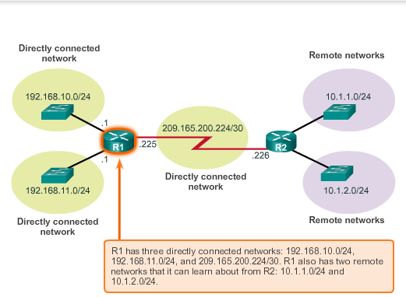

### 6.2.2.2 IPv4 Router-Routing Table

Host routing table includes only info about directly connected networks, routing table of router contains similar info + can identify specific remote networks

Cisco IOS router -> show ip route -> routing table router

### 6.2.2.3 Directly Connected Routing Table Entries

Direct connection interfaces Entries contain the following info:

**Route Source**

* How was the route learned? Directly connected interfaces have two route source codes:
  + C: Identifies a directly connected network, automatically created when an interface is configured with an IP address and activated
  + L: identifies this is a link local route. Link local routes are automatically created when an interface is configured with an IP address and activated

**Destination network**

* Identifies the address of the remote network

**Outgoing interface**

* Identifies the exit interface to use when forwarding packets to the destination network

Codes for remote network

* S: route was manually created, static route
* D: route was learned dynamically from another router using Enhanced Interior Gateway Routing Protocol (EIGRP)
* O: identifies that the route was learned dynamically from another router using the Open Shortest Path First (OSPF) routing protocol

### 6.2.2.4 Remote Network Routing Table Entries

Routing source: Identifies how the route was learned

Destination network: Identifies the address of the remote network

Administrative distance: Identifies the trustworthiness of the route source

Metric: Identifies the value assigned to reach the remote Network

Next-hop: Identifies the IP address of the next router to forward the packet

Route timestamp: Identifies when the route was last heard from

Outgoing interface: identifies the exit interface to use to forward a packet toward final destination

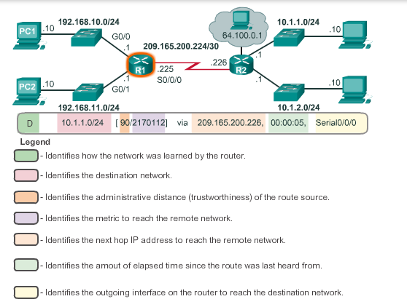

### 6.2.2.5 Next-Hop Address

Address of the device that will process the packet next

If a route representing the destination network is not in the routing table, the packet is dropped

### 6.2.2.6 Sample Router IPv4 Routing Table

Look at example

# 6.3 Routers

## 6.3.1 Anatomy of a Router

### 6.3.1.1 A Router is a Computer

Cisco Routers are designed to address the needs of:

* Branch – Teleworkers, small business and medium-size branch sites
* WAN – Large business, organizations and enterprises
* Service Provider: Large service providers

Routers require:

* Operating System
* Central Processing Units
* Random-Access Memory
* Read-only memory ROM

A router has also special memory that includes Flash and nonvolatile random-access memory (NVRAM)

### 6.3.1.2 Router CPU and OS

OS: Cisco Internetwork Operating System

### 6.3.1.3 Router Memory

**RAM**

Used to store various applications and processes including:

* Cisco IOS, during bootup
* Running configuration file
* IP routing table
* ARP cache
* Packet Buffer

Like Computers Cisco Routers actually use dynamic random-access memory (DRAM)

**ROM**

Cisco Routers use ROM to store:

* Bootup instructions
* Basic diagnostic software: Performs the power-on self test (POST) of all components
* Limited IOS: limited backup version of the OS in case the full featured IOS could not be loaded

**NVRAM**

Used as permanent storage for the startup configuration file

**Flash Memory**

Used as permanent storage, IOS copied from flash to RAM during bootup

### 6.3.1.4 Inside a router

### 6.3.1.5 Router Backplane

A Cisco router includes the following connections:

* Console ports:
* AUX port (rj-45)
* 2 LAN interfaces
* Enhanced high-speed WAN interface card (EHWIC)

### 6.3.1.6 Connecting to a Router

The connections on a Cisco router can be grouped into two categories:

* Management ports: console and auxiliary port
* Inband router interfaces: LAN and WAN interfaces configured with IP addressing to carry user traffic. Ethernet interfaces most common LAN connections, common WAN connections: serial and DSL interfaces

### 6.3.1.7 LAN and WAN Interfaces

Every interface on the router is a member or host on a different IP network

* Each interface must be configured with an IP address and subnet mask of a different network

Router interfaces can be grouped into two categories:

* Ethernet LAN interfaces
* Serial WAN interfaces: connecting routers to external networks, usually over a larger geographical distance

## 6.3.2 Router Boot-up

### 6.3.2.1 Cisco IOS

Cisco IOS for routers provides the following:

* Addressing
* Interfaces
* Routing
* Security
* QoS
* Resources Management

### 6.3.2.2 Bootset Files

Router loads the following two files into RAM when it is booted:

* IOS image file from flash
* Startup configuration file from NVRAM, configuration changes stored in running configuration file

### 6.3.2.3 Router Bootup Process

Three major phases to the bootup process

* Perform POST and load the bootstrap program
* Locate and load the Cisco IOS software
* Locate and load the startup configuration file or enter setup mode

**1 Perform POST and load Bootstap Program**

POST process used to test router hardware

After the POST, the bootstrap program is copied from ROM into RAM, once in RAM the CPU executes instructions in the bootstrap program.

Main task bootstrap program is to locate the Cisco IOS and load it into RAM

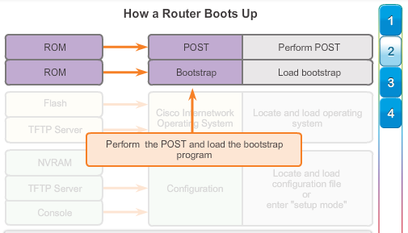

**2 Locating and loading Cisco IOS**

IOS stored in flash memory and copied into RAM

During self-decompressing of the IOS image file, string of # will be displayed

If the IOS image is not located in flash, then the router may look for it using a TFTP server. If a full IOS image cannot be located, scaled down version of the IOS is copied from ROM into RAM

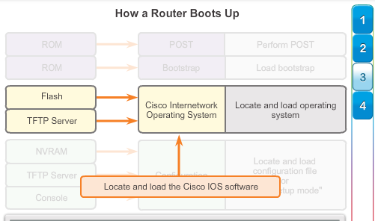

**3 Locating and Loading the configuration File**

If the startup-config file does not exist in NVRAM, the router may search for a Trivial File Transfer Protocol (TFTP) server, if the router detects that it has an active link to another configured router it sends a broadcast searching for a configuration file across the active link

If a TFTP server is not found, then the router displays setup mode prompt

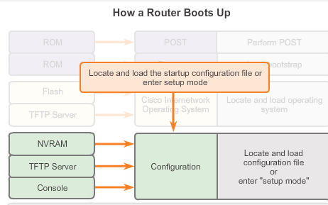

### 6.3.2.4 Show Version Output

Show version command to verify and troubleshoot some basic hardware and software components

Output includes:

* IOS version
* ROM bootstrap program: version of system bootstrap software
* Location of IOS
* CPU and amount of RAM
  + First part of line: type of CPU, last part: amount of DRAM
  + Some routers use fraction of DRAM as packet memory, to know total DRAM: add both numbers
* Interfaces: physical interfaces
* Amount of NVRAM and flash

Configuration register has several uses, password recovery, factory default settings = 0X2102

# 6.4 Configuring a Cisco Router

## 6.4.1 Configuring Initial Settings

### 6.4.1.1 Router configuration Steps

Same stuff as with switches, device name, passwords, motd, saving

## 6.4.2 Configure Interfaces

### 6.4.2.1 Configuring LAN Interfacs

For routers to be reachable, router interfaces must be configured -> enter interface configuration mode using: interface type –and-number global configuration mode command

To enable a router interface configure the following

* IPv4 address and subnetmask: ip address ip-address subnet-mask
* Activate the interface: no shutdown

Useful: adding a description: description description (can be 240 chars long)

### 6.4.2.2 Verify Interface Configuration

Most usefull: show ip interface brief

* Generates all interfaces, their IP address and their current status

Connection can be verified by ping (5 times does it do it) ! is a good thing

Other interface verification commands:

* Show ip route: contents of IPv4 routing table in RAM
* Show interfaces: statistics for all interfaces on the device
* Show ip interfaces: displays the IPv4 statistics for all interfaces on a router

## 6.4.3 Configuring the Default Gateway

### 6.4.3.1 Default Gateway on a Host

IP address of the host device and the router interface address must be in the same network

### 6.4.3.2 Default Gateway on a Switch

IP address information on a switch is only necessary to manage the switch remotely

Configuring the IP address on a switch is done on the switch virtual interface (SVI) – VLAN

But if the switch must be accessible by devices in a different network, the switch must be configured with a default gateway address

* Ip default-gateway ipaddress

# Chapter 7: Transport Layer

## 7.0.1 Introduction

### 7.0.1.1 Introduction

The transport layer prepares data for transmission across the network.

Source computer communicates with a receiving computer to decide how to break up data into segments, how to make sure none of the segments et lost and how to verify if all segments arrived

Other functions transport layer:

* Enables multiple applications to communicate over the network at the same time on a single device
* Ensures that (if required) that all data is received reliably and in order
* Employs error handling mechanisms

# 7.1 Transport Layer Protocols

## 7.1.1 Transportation of Data

### 7.1.1.1 Role of the Transport Layer

Transport layer is responsible for establishing a temporary communication session between two applications and delivering data between them

In TCP/IP segmentation and reassembly processes can be achieved by two very different transport layer protocols:

* Transmission Control Protocol (TCP)
* User Datagram Protocol (UDP)

Primary responsibilities of transport layer protocols:

* Tracking individual communication between applications on the source and destination hosts
* Segmenting data and reassembling
* Identifying the proper application for each communication stream

**Tracking Individual Conversations**

Each particular set of data flowing between a source application and a destination application = conversation -> Transport layer needs to track ‘em all

**Segmenting Data and Reassembling Segments**

Most networks have a limitation on the amount of data that can be included in a single packet

Header of transport layer needed for reassembly and to track data stream

**Identifying the Applications**

To pass data streams to the proper applications, transport layer must identify the target application

To accomplish this, the transport layer assigns each application an identifier -> port number

### 7.1.1.3 Conversation Multiplexing

**Conversation Multiplexing**

Sending some types of data (e.g video) as one complete communication stream, could use all of the available bandwidth

* Segmenting the data into smaller chunks enables many different communication to be interleaved (multiplexed) on the same network

### 7.1.1.4 Transport Layer Reliability

Different applications have different transport reliability requirements

IP is only concerned with the structure, addressing and routing of packets, Transport protocols specify how to transport messages between hosts -> two protocols TCP and UDP

TCP = reliable, ensures that all of the data arrives at the destination

UDP = does not provide for any reliability

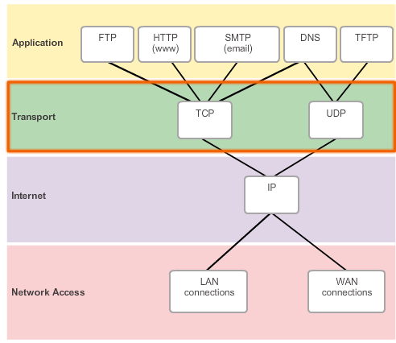

### 7.1.1.5 TCP

Uses acknowledged delivery

Three basic operations of reliability:

* Tracking transmitted data segments
* Acknowledging received data
* Retransmitting any unacknowledged data

TCP breaks message up into segments, segments are numbered in sequence and passed to the IP process for assembly into packets -> TCP keeps track of the number of segments that have been sent to a specific host from a specific application

* If the sender does not receive an acknowledgement within a certain amount of time, it resends the data
* On receiving host: TCP reassembles data and passes data to the application (File Transfer Protocol (FTP) and Hypertext Transfer Protocol (HTTP) examples

Reliability processes place additional overhead -> acknowledgement, tracking, retransmission

### 7.1.1.6 UDP

Imposing overhead to ensure reliability for some applications could reduce the usefulness of the application -> use UDP

UDP is best-effort delivery protocol -> unreliable -> no transport layer processes that inform the sender if successful delivery has occurred

### 7.1.1.7 The Right Transport Layer Protocol for the Right Application

If segments must arrive in a very specific sequence to be processed successfully or data must be fully received before it is considered useful -> TCP

* Databases, web browsers, email clients

If application can tolerate some data loss, but delays in transmission unacceptable -> UDP

* Streaming audio, video, Voice over IP

## 7.1.2 Introducing TCP and UDP

### 7.1.2.1 Introducing TCP

**Transmission Control Protocol (TCP)**

It also provides:

* Connection-oriented conversations by establishing sessions
* Reliable delivery
* Ordered data reconstruction
* Flow Control

**Establishing a Session**

Connection-oriented = establishes a permanent connection (session) between source and destination devices prior to forwarding any traffic.

Through session establishment, the devices negotiate the amount of traffic that can be forwarded

Session terminated if all communication is completed

**Reliable Delivery**

Retransmitting lost/corrupted data

**Same-Order Delivery**

Numbering and sequencing segments ensures that segments are reassembled into the proper order

**Flow Control**

When TCP is aware that the network hosts resources are overtaxed, it can request the sending application to reduce the rate of data flow -> TCP regulating the amount of data the source transmits

### 7.1.2.2 Role of TCP

Because of the ability of TCP to track actual conversations, it is considered a stateful protocol

* Protocol that keeps track of the state of the communication session
* Stateful session begins with the session establishment and ends when the session is closed with session termination

TCP has 20 bytes of overhead in the header, UDP has only 8

* Sequence number (32 bit): Used for data reassembly purposes
* Acknowledgement number (32 bits): Indicates the data that has been received
* Header length (4 bits): data offset -> length of TCP segment header
* Reserved (6 bits): reserved for the future
* Control bits (6 bits): bit codes/flags that indicate the purpose and function of the TCP segment
* Window size (16 bits): Indicates the number of segments that can be accepted at one time
* Checksum (16 bits): Used for error checking
* Urgent (16 bits):

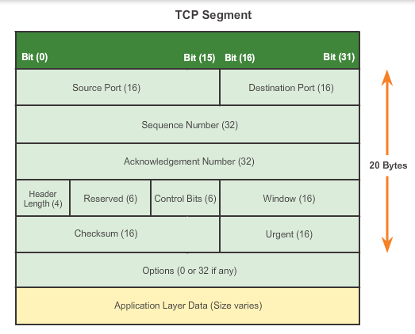

### 7.1.2.3 Introducing UDP

**User Datagram Protocol (UDP)**

Offers the same data segmentation and reassembly as TCP, but without TCP reliability and flow control

Following features describe UDP:

* Connectionless: UDP does not establish a connection between hosts before data can be sent and received
* Unreliable Delivery: UDP does not provide services to ensure that the data will be delivered reliably
* No Ordered Data Reconstruction – Occasionally data is received in a different order than it was sent -> UDP does not provide any mechanism for reassembling data in its original sequence
* No Flow Control: no mechanisms within UDP to control the amount of data transmitted by the source to avoid overwhelming the destination device

### 7.1.2.4 Role of UDP

The pieces of communication in UDP are called datagrams

* Applications that use UDP: DNS (Domain Name System), video streaming and Voice over IP (VoIP)

UDP is a stateless protocol -> neither the client, nor the server is obligated to keep track of the state of the communication session

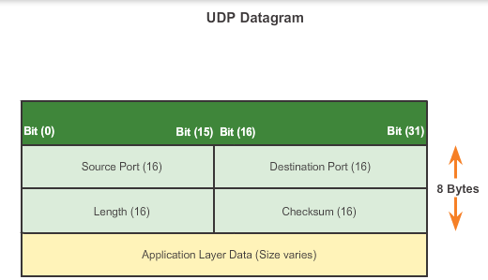

### 7.1.2.5 Separating Multiple Communications

To differentiate the segments and datagrams for each application, both TCP and UDP have header fields that can uniquely identify these applications -> port numbers

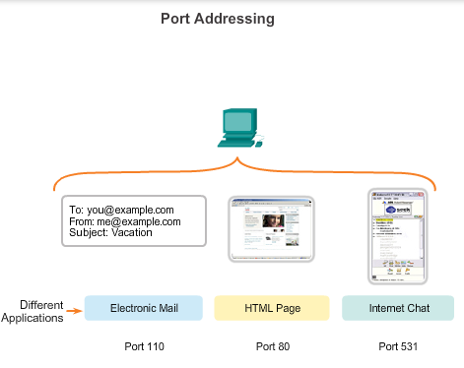

### 7.1.2.6 TCP and UDP Port Addressing

In the header of each segment or datagram, there is a source and destination port

* Port is a numeric identifier within each segment that is used to keep track of specific conversations and destination services requested

**Destination Port**

To tell the destination server what service is being requested -> a server van offer more than one service simultaneously

**Source Port**

Randomly generated by the sending device to identify a conversation between two devices

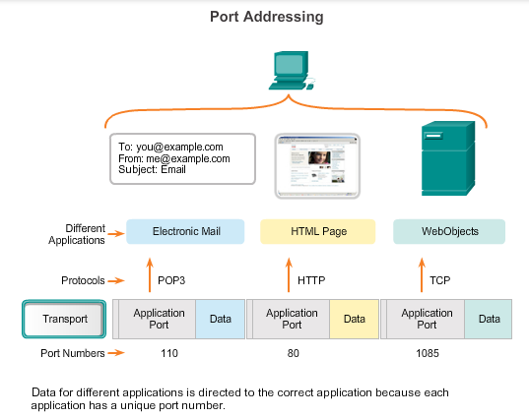

Segments encapsulated within IP packet -> combo of IP address of source and destination and the source and destination port numbers -> socket

* Socket used to identify the server and service being requested by the client

Combo of transport layer port number and network layer IP address of host ->identifies particular application processes running on an individual host device

The Internet Assigned Numbers Authority (IANA) assigns port numbers

Different types of port numbers:

* Well-known Ports (0 – 1023): reserved for services and applications -> HTTP, Internet Message Access Protocol, Simple Mail Transfer Protocol, Telnet
* Registered Ports ( 1024 – 49151): assigned to user processes or applications (applications that do not have a well-known port) – When not used for a server recourse, ports may be dynamically selected by a client as its source port
* Dynamic or Private Ports (49152 – 65535): ephemeral ports. Used to identify the client application during communication (although mostly the well-known port is used for that, some peer-to –peer uses this

**Using both TCP and UDP**

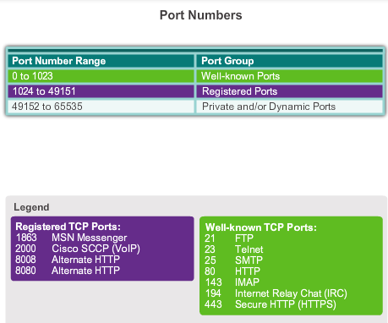

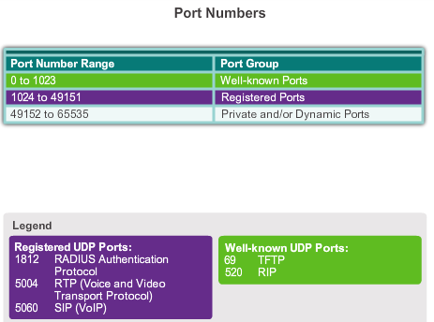

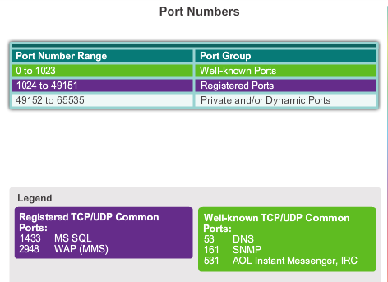

Sometimes it is necessary to know which active TCP connections are open and running on a networked host -> Netstat

* Netstat lists the protocol in use, the local address and port number, the foreign address and port number and the connection state

Unexplained TCP connections can pose a major security threat -> can indicate that something or someone is connected to the local host

Unnecessary TCP connections can consume valuable system resources

### 7.1.2.10 TCP and UDP Segmentation

**TCP and UDP Handle Segmentation Differently**

TCP header contains a sequence number -> reassembling (absent in UDP)

Application that uses UDP must tolerate the fact that data may not arrive in the order in which it was sent

# 7.2 TCP and UDP

## 7.2.1 TCP Communication

### 7.2.1.1 TCP Reliable Delivery

Reliability of TCP obtained through the use of connection-oriented sessions -> before sending data, a connection is created

After session is established and data transfer begins -> destination sends acknowledgements to the source for the segments that it receives

### 7.2.1.2 TCP Server Processes

An individual server cannot have two services assigned to the same port number within the same transport layer services

A host running a web server application and a file transfer application cannot have both configured to use the same port

One way to improve security on a server is to restrict server access to only those ports associated with the services and applications that should be accessible

### 7.2.1.3 TCP Connection Establishment and Termination

First handshake: Request synchronization

Second handshake: Acknowledges the initial synchronization request and synchronizes the connection parameters in the opposite direction

Third handshake: acknowledgement used to inform the destination that both sides agree that a connection has been established

TCP is a full-duplex protocol

* To establish the connection, the hosts perform a three-way handshake -> Control bits in the TCP header indicate the progress and status of the connection. The three-way handshake:
  + Establishes the destination device is present on the network
  + Verifies that the destination device has an active service and is accepting requests on the destination port number that the initiating client intends to use
  + Informs the destination device that the source client intends to establish a communication session on that port number

### 7.2.1.4 TCP Three-way Handshake Analysis – Step 1

**Step 1: The initiating client requests a client-to-server communication session with the server**

TCP client begins the three-way handshake by sending a segment with the synchronize sequence number (SYN) control flag set -> indicating an initial value in the sequence number field (Initial Sequence number ISN, randomly chosen)

### 7.2.1.5 TCP Three-way Handshake Analysis – Step 2

**Step 2: The server acknowledges the client-to-server communication session and requests a server-to-client communication session**

The TCP server must acknowledge the receipt of the SYN segment from the client to establish the session from the client to the server

* Server sends a segment back to the client with the ACK (acknowledgement) flag set indicating that the acknowledgement number is significant

Value of acknowledgement number field = ISN +1 -> this establishes a session from the client to the server

Server must initiate the response to the client -> same as the client did to establish a session from the server to the client

### 7.2.1.6 Three-way Handshake Analysis – Step 3

**Step 3: The initiating client acknowledges the server-to-client communication session**

The TCP client responds with a segment containing an ACK that is the response to the TCP SYN sent by the server, after both sessions are established between client and server, all additional segments exchanged in this communication will have the ACK set

Security can be added to the data network by:

* Denying the establishment of TCP session
* Only allowing sessions to be established for specific services
* Only allowing traffic as a part of already established sessions

### 7.2.1.7 TCP Session Termination Analysis

To close a connection, the Finish (FIN) control flag must be set in the segment header

* To end each one-way TCP session, a two-way handshake is used -> FIN segment and an ACK segment

Ending a session can either be done by server or client!

Step 1: When client has no more data to send in the stream -> sends a segment with the FIN flag set

STEP2: The server sends an ACK to terminate the session from client to server

STEP3: The server sends a FIN to the client to terminate the server to client session

Step 4: The client responds with an ACK

It is also possible to terminate the connection by a three-way handshake

* No more data to send: FIN to server
* If the server too has nothing more to send: FIN +ACK
* Client replies with ACK

## 7.2.2 Reliability and Flow Control

### 7.2.2.1 TCP Reliability – Ordered Delivery

**Resequencing Segments**

During session setup an initial sequence number (ISN) is set. ISN represents the starting value for the bytes for this session that is transmitted to the receiving application. As data is transmitted during the session, the sequence number is incremented by the number of bytes that have been transmitted

Receiving TCP process places the data from a segment into a receiving buffer, segments are placed in the proper sequence number order and passed to the application layer when reassembled

### 7.2.2.2 TCP Reliability – Acknowledgement and Window Size

**Confirming Receipt of Segments**

The sequence (SEQ) number and acknowledgement(ACK) number are used together to confirm receipt of the bytes of data contained in the transmitted segments

* SEQ: indicates the relative number of bytes that have been transmitted in this session (incl. bytes current segment)
* TCP uses the ACK that has been sent back to the source to indicate the next byte that the receiver expects to receive -> Expectional Acknowledgement
  + Source is informed that the destination has received all bytes in this data stream up to, but not including the byte indicated by the ACK number -> sending host is expected to send a segment that uses a sequence number that is equal to the ACK number
  + Amount of data that a source can transmit before an acknowledgement must be received -> window size

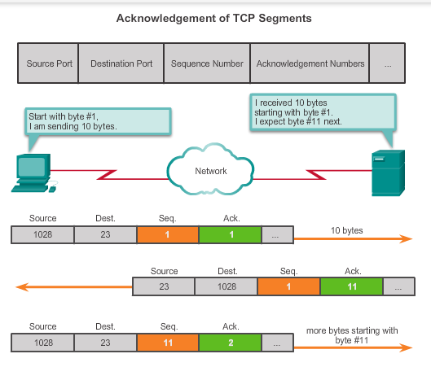

### 7.2.2.3 TCP Reliability – Data Loss and Retransmission

**Handling Segment Loss**

A destination host service using TCP usually only acknowledges data for contiguous sequence bytes. If one or more segments are missing, only the data in the first contiguous sequence of bytes is acknowledged

When TCP at the source host has not received an acknowledgement after a predetermined amount of time, it returns to the last ACK number received and retransmits the data from that point forward (not specified by the Request for Comments (RFC) but left up to the particular implementation of TCP)

* Transmit segment, put copy in retransmission queue and start timer
  + Acknowledgement received -> copy deleted, else retransmit
* Host today may have the optional feature selective acknowledgements (SACKs), if both hosts support it, it is possible for the destination to acknowledge bytes in discontinuous segments -> only transmitting missing data

### 7.2.2.4 TCP Flow Control – Window Size and Acknowledgements

**Flow Control**

First thing that TCP determines is the amount of data segments that the destination device can accept -> window size in the header

* Initial window size agreed upon during the session startup via the three-way handshake between source and destination

### 7.2.2.5 TCP Flow Control – Congestion Avoidance

**Reducing Window Size**

Receiving host sends the window size value to the sending host, indicating the number of bytes that it is prepared to receive

After a period of transmission with no data losses or constrained resources, the receiver begins to increase window field -> less overhead (less acknowledgements)

## 7.2.3 UDP Communication

### 7.2.3.1 UDP Low Overhead versus Reliability

Key application layer protocols that use UDP:

* Domain Name System (DNS)
* Simple Network Management Protocol (SNMP)
* Dynamic Host Configuration Protocol (DHCP)
* Routing Information Protocol (RIP)
* Trivial File Transfer Protocol (TFTP)
* IP telephony or Voice over IP (VoIP)
* Online games

### 7.2.3.2 UDP Datagram Reassembly

Sessions not established before communication takes place (different with TCP) -> transaction based -> it just sends the data when it needs to be send

Data is reassembled in the order that it was received (may differ with the order in which it was send), if data sequence is important to the application, application must identify the proper sequence

### 7.2.3.3 UDP Server Processes and Requests

Same as TCP

### 7.2.3.4 UDP Client Processes

UDP client randomly selects a port number from the range of dynamic port numbers and uses this as the source port for the conversation, destination port is usually the well-known or registered port number assigned to the server process

* Randomized source port numbers also help with security -> if there is a predictable pattern for destination port selection, intruder can more easily simulate access to a client by attempting to connect to the port number most likely to be open

## 7.2.4 TCP or UDP that is the Question

### 7.2.4.1 Applications that use TCP

Hypertext Transfer Protocol (HTTP)

File Transfer Protocol (FTP)

Simple Mail Transfer Protocol (SMTP)

Telnet

### 7.2.4.2 Applications that use UDP

Three types of applications that are best suited for UDP:

* Applications that can tolerate some data loss, but require little or no delay
* Applications with simple request and reply transactions
* Unidirectional communication where reliability is not required or can be handled by the application

Some applications handle reliability themselves -> no need for TCP -> TFTP is an example

Cisco Chapter 8: IP Addressing

# 8.0 IP Addressing

## 8.0.1 Introduction

### 8.0.1.1 Introduction

## 8.1.1 IPv4 Address Structure

### 8.1.1.1 Binary Notation

**Positional Notation**

Digit represents different values depending on the position the digit occupies (12 -> 1 Is eigenlijk 10 = 1*10^1)

Number base = radix -> binair = 2

### 8.1.1.2 Binary Number System

Byte = octet

Dotted decimal: 192.168.10.10

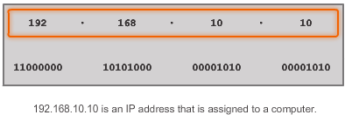

### 8.1.1.3 Converting a Binary Address to Decimal

### 8.1.1.5 Converting from Decimal to Binary

## 8.1.2 IPv4 Subnet Mask

### 8.1.2.1 Network Portion and Host Portion of an IPv4 Address

Bits within the network portion of the address must be identical for all devices that reside in the same network, host portion must be unique

Subnet mask identifies which part of IP address is network and which is host

* 1 represents network address, 0 = host portion (bit wise)
* Dotted decimal

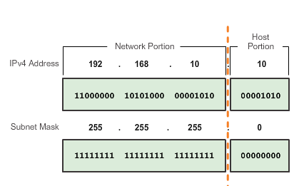

### 8.1.2.2 Examining the Prefix Length

**Network Prefixes**

Prefix length is another way of expressing the subnet mask -> number of bits set to 1 in subnetmask

* Slash notation followed by number of bits set to 1

Networks are not always assigned a /24 prefix -> depends on number of hosts

* Network address could remain the same, host range and broadcast address are different for the different prefix lengths

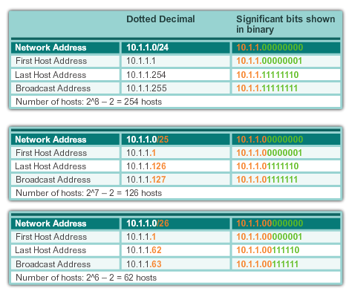

### 8.1.2.3 IPv4 Network, Host and Broadcast Addresses

Three types of addresses within the address range of each IPv4 network:

* Network address
* Host addresses
* Broadcast address

**Network Address**

Standard way to refer to a network (subnet mask or prefix length might also be used when referring to network address

**Host Address**

Cannot contain all 0 bits or all 1 bits!!!

**Broadcast Address**

Uses the highest address in the network range -> host portion of all 1’s -> 255

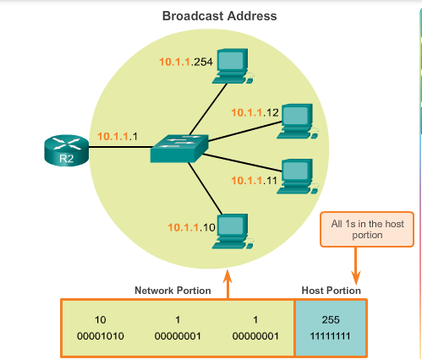

## 8.1.2.4 First Host and Last Host Addresses

**First Host Address**

One bit higher than the network address -> 10.1.1.0/24 => 10.1.1.1

**Last Host Address**

Host portion of the last host address will contain all 1 bits with a 0 bit for the lowest order (right most bit) -> one less than broadcast address

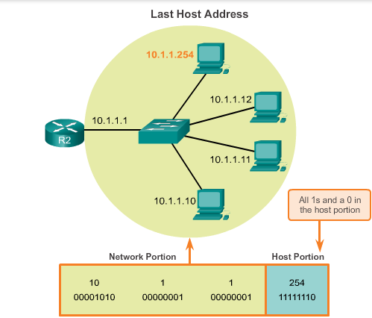

### 8.1.2.5 Bitwise AND Operation

When a host sends a packet, it compares the network portion of its own IP address to the network portion of the destination IP address, based on subnet masks -> no match, to the default gateway

**The AND Operation**

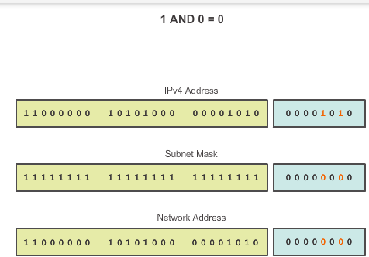

### 8.1.2.6 Importance of ANDing

Properties of ANDing are used with the subnetmask to “mask” the host bits of an IPv4 address

In network verification/troubleshooting, we often need to determine two hosts are on the same local network

### 8.1.3.1 Assigning a Static IPv4 Address to a Host

**Addresses for User Devices**

Static or Dynamic

**Static Assignment**

Advantages of static addressing:

* Useful for printers, servers and other networking devices that do not change location often and need to be accessible to clients on the network based on a fixed IP address
* Increased control of network resources -> access filters

Disadvantages

* Time consuming

### 8.1.3.2 Assigning a Dynamic IPv4 Address to a Host

**Dynamic Assignment**

Easier to have IP addresses assigned automatically -> Dynamic Host Configuration Protocol (DHCP)

Configuration of the DHCP server requires that a block of addresses (address pool) is used for assigning to the DHCP clients on a network

Advantages (obviously this is the preferred method)

* Reduces burden on network support staff + reduces entry errors
* Address is not permanently assigned to a host, just leased for short period -> user goes off network/powered down, address goes back to the address pool, for reuse)

If DHCP is enabled -> ipconfig command can be used to view the IP address

### 8.1.3.3 Unicast Transmission

In a IPv4 network, hosts can communicate one of three ways:

* Unicast – packet from one host to an individual host
* Broadcast – packet from one host to all hosts in the network
* Multicast – packet from one host to a selected group of hosts, possibly in different networks

**Unicast Traffic**

In IPv4 network, unicast addresses applied to an end device = host address (used as source/destination IPv4)

Regardless of whether the destination specified a packet is a unicast, broadcast or multicast -> source address is always unicast address

**Unicast Range -> 0.0.0.0 – 223.255.255.255**

* Within this range are many addresses that are reserved for special purposes
* 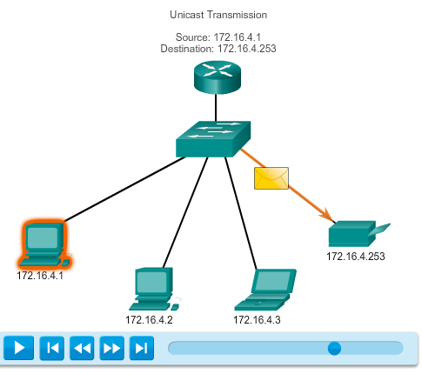

### 8.1.3.4 Broadcast Transmission

**Broadcast Transmission**

Many network protocols (such as DHCP) use broadcasts

Examples for using broadcast transmission:

* Mapping upper layer addresses to lower layer addresses
* Requesting an address
* **BROADCAST PACKETS ARE USUALLT RESTRICTED TO THE LOCAL NETWORK**
  + **Restriction dependent on configuration of gateway router and type of broadcast**
    - **Directed and limited broadcast (types)**

**Directed Broadcast**

Useful for sending a broadcast to all hosts on a non-local network

For a host outside of the 172.16.4.0/24 network to communicate with all hosts within that network a destination address of the packet would be 172.16.4.255

**Although routers do not forward directed broadcasts by default, they may be configured to do so!**

**Limited Broadcast**

Limited to the hosts on the local network -> Destination IPv4 address of 255.255.255.255

Routers do not forward a limited broadcast -> IPv4 network = broadcast domain, routers form the boundary for a broadcast domain

Broadcast traffic should be limited -> it consumes a great deal of resources

* Routers separate broadcast domains, subdividing networks with excessive broadcast traffic can improve network performance

### 8.1.3.5 Multicast Transmission

**Multicast Transmission**

Designed to conserve the bandwidth of an IPv4 network

Better than unicast: instead of sending multiple packets to each IP address, the sender now needs to send only one packet -> internetworks need to replicate the multicast

Examples of multicast transmissions:

* Video and audio broadcasts
* Routing information exchange by routing protocols
* Distribution of software
* Remote gaming

**Multicast Addresses**

Range: 224.0.0.0 – 239.255.255.255

Divided into different types of addresses:

* Reserved link local addresses: 224.0.0.0 – 224.0.0.255
  + Multicast groups on a local network, router connected to the local network does not forward this!
* Globally scoped addresses: 224.0.1.0. – 238.255.255.255
  + Multicast data across the Internet (e.g.: 224.0.1.1 reserved for Network Time Protocol (NTP) to synchronize time-of-day clocks for network devices
* Additionally: administratively scoped addresses (limited scope addresses)

**Multicast Clients**

Hosts that receive particular multicast data are called multicast clients, they use services requested by a client program to subscribe to the multicast group

## 8.1.4 Types of IPv4 Addresses

### 8.1.4.1 Public and Private IPv4 Addresses

Most IPv4 host addresses are public addresses, designated for use in networks that are accessible on the Internet

There are however blocks of addresses that are used in networks that require limited or no Internet access -> Private addresses

**Private Addresses**

10.0.0.0 – 10.255.255.255 (10.0.0/8)

172.16.0.0 – 172.31.255.255 (172.16.0.0/12)

192.168.0.0 – 192.168.255.255 (192.168.0.0/16)

Defined in RFC 1918, Address Allocation for Private Internets, sometimes referred to as RFC 1918 addresses

Even within the private network, hosts still require unique IP addresses within the private space

Hosts in different networks may use the same private addresses!! Because packets using these addresses should not appear on the public Internet -> router/firewall blocks these private networks or must translate the addresses

RFC 6598, IANA reserved another group of addresses known as shared address space, these are also not globally routable -> intended only for use in service provider networks

* 100.64.0.0/10

**Public Addresses**

Designed to be used in the hosts that are publicly accessible from the Internet

Even within these IPv4 address blocks, there are many addresses that are designated for other special purposes

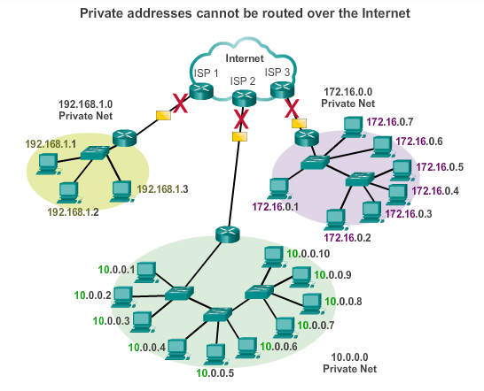

### 8.1.4.3 Special Use IPv4 Addresses

**Network and Broadcast Addresses**

**Loopback**

127.0.0.1, used by hosts to direct traffic to themselves

By using the loopback address instead of the assigned IPv4 host address, two services on the same host can bypass the lower layer of the TCP/IP stack

Although only the single 127.0.0.1 address is used -> 127.0.0.0 – 127.255.255.255 are reserved

**Link-Local Addresses**

169.254.0.0 – 169.254.255.255 (169.254.0.0/16) designated as link-local addresses

Can be automatically assigned to the local host by the operating system in environments where no IP configuration is available

Small peer-to-peer network or for host that could not automatically obtain an address from a DHCP serer

Router does not forward this (duh), TTL time to live must be set to 1

**TEST-NET Addresses**

* 192.0.2.0 – 192.0.2.255 for teaching and learning
* Network devices will accept these addresses in their configurations
* Domain names as example.com example.net
* Addresses should not appear on the Internet

**Experimental Addresses**

* 240.0.0.0 – 255.255.255.254 -> future use
* Research/experimental purposes
* Cannot be used on IPv4 network

### 8.1.4.4 Legacy Classful Addressing

**Class A Blocks**

* Designed to support extremely large networks (more than 16 million host addresses)
* Fixed /8 prefix
* Most significant bit of network address= 0 => 128 possible class A networks: 0.0.0.0/8 – 127.0.0.0/8

**Class B Blocks**

* Moderate to large size networks (65.000 hosts)
* Prefix: 16
* Most significant 2 bits= 10 => 128.0.0.0/16 – 191.255.0.0/16
* Slightly more efficient allocation of addresses than class A

**Class C Blocks**

* Most commonly available of the historic address classes -> small networks (max 254 hosts)
* /24 prefix
* Most significant 3 bits: 110 => 192.0.0.0/24 – 223.255.255.0/24

**Limits to the Class-based System**

* Not all organizations’ requirements fit well into one of these classes
* Classful system abandoned in late 90’s, but there are still remains -> assigning IPv4 address to computer -> OS examines the address to determine which class it is and then assumes the corresponding prefix

**Classless Addressing**

* Classless Inter Domain Routing (CIDR)
* Allows to allocate IPv4 addresses on any bit boundary (prefix length)
* Temporary solution until IPv6 arrives

### 8.1.4.5 Assignment of IP Addresses

* Need of public addresses to be accessible from the internet
* Public addresses are unique

**IANA and RIRs**

* Managed allocation of IPv4 and IPv6 addresses until mid 90’s
* RIR’s managed the remaining IPv4 addresses (Regional Internet Registries (for each contintent 1)

**ISPs**

* RIRs are responsible for allocating IP addresses to the Internet Service Providers (ISPs)
* Most companies obtain their IPv4 address blocks from an ISP
* Supply (6-14) usable IPv4 addresses to their customers, larger blocks => justification of needs
* IPv6 addresses can be obtained from ISP, or directly from the RIR

**ISP Services**

* ISPs have their own set of internal data networks to manage internet connectivity and to provide related services
* They generally provide also DNS, email services and a website
* Depending on the level of services required and available, customers use different tiers of an ISP

**ISP Tiers**

* Hierarchy, lower tier obtains connectivity to the backbone via a connection to a higher tier ISP

**Tier 1**

* Top of ISP hierarchy
* Large national/international ISPs directly connected to the Internet backbone
* Custormers: lower tiers or large companies
* Highly reliable connections and speed (one connection away from the Internet)

**Tier 2**

* Focus on business customers
* Have IT resources to operate their own services (DNS, email servers, web servers)
* Other possible services: website development and maintenance, e-commerce/e-business and VoIP

**Tier 3**

* Retail and homes
* They usually do not need many of the services required by tier 2 customers
* Connectivity and support only requirements
* Small to medium sized companies